Computer networks: assignment 1

**Student number:ST10467645**

**Full Name: Kandyce Jade Smit**

**Lecturer: Samuel Kubjana**

**Computer Networks 1A (CONE5111)**

Contents

Activity 1 Network Topology, Model and Hardware 3

Activity 2 Network Addressing and Services 11

Activity 3 Network Cables and Cabling 14

Activity 4 Network Documentation 22

Activity 5 Capstone projects and reflection report 26

Reflection Report 77

Bibliography 78

# Activity 1 Network Topology, Model and Hardware

#### 1. Network Topology

**a)**

|  |  |
| --- | --- |
| Table of **Network Topologies** | |
| **Column A** | **Column B** |
| **List two types of network topologies** | **Topology description, role, advantages and disadvantages** |
| 1. Star Topology | A star topology is when all devices are connected to a central point, such as a switch or a hub. The hub or switch manages communication and traffic between the devices. (The Knowledge Academy, 2025)  Advantages of a star topology include:   * Makes troubleshooting easier. * It is Scalable * It is easy to install and configure * (The Knowledge Academy, 2025)   Disadvantages of a star topology include:   * Tends to be more expensive than other topologies. * Relies on a central point, for example a switch, therefore if it goes down, the whole network will go down. * The maintenance needs are high as the switch required for the topology requires regular updates. * (The Knowledge Academy, 2025) |
| 1. Hybrid Topology | A hybrid topology is combining different types of network topologies, two or more, into one. This adds flexibility to your network. (NAKIVO, 2021)  Advantages of a hybrid topology include:   * It is scalable * It will share the advantages of the child topologies, meaning that if it includes a star topology, it will also benefit from the advantages of star topologies, such as easier troubleshooting and being easy to install and configure. * (NAKIVO, 2021)   Disadvantages of a hybrid topology include:   * Combines the disadvantages of the child topologies * More complex to install and configure * Can include additional costs making it more expensive * (NAKIVO, 2021) |
| 1. Tree Topology | A tree topology is like a bigger version of a star topology where multiple star networks connected by connecting different devices through switches like branches on a tree. This makes it easier to manage large networks and allows for better organisation and scalability. (NAKIVO, 2021)  Advantages of a tree topology include:   * It is scalable * Easy troubleshooting * Easy to install and maintain * (NAKIVO, 2021)   Disadvantages of a tree topology include:   * If one of the switches stops working, all the devices connected to it won’t be able to access the network. * If the main switch stops working, the different branches won’t be able to connect with each other, thus making them unable to communicate. * (NAKIVO, 2021) |
|  |  |
|  |  |
|  | |

**b)**

I have selected the Hybrid Topology, specifically the Star-Tree Hybrid Topology. This Topology combines both the advantages of a star and tree topology, making it reliable, scalable and highly secure.

The role in the topology for the network solution to work:

* This topology allows for each department to be connected and ensures efficient data flow as they are connected to a central switch.
* A server room will control the data flow between the different departments, therefore having centralised control and enhancing security
* As this topology is easily scalable it allows for easy expansion in any of the departments if needed as well as it ensures easy troubleshooting.
* This topology allows for the rest of the network to not be affected if one workstation fails.
* (Geeks For Geeks, 2024)

#### 2. Network Model

|  |  |
| --- | --- |
| Table of **Network Models** | |
| Column A | Column B |
| List two types of network models | Model description, role, advantages and disadvantages |
| 1. Peer-peer-network (p2p) | A peer-to-peer network is a type of network structure where peers connect and interact with each other directly without needing authorisation from a central server. In this kind of network, everyone plays both the role of a client and a server, which allows them to share resources and services with one another directly. (Spice Works, 2023)  Advantages of a peer-peer-network model include:   * Easily scalable * Inexpensive * (Spice Works, 2023)   Disadvantages of a peer-peer-network model include:   * Security concerns * No centralised control * (Spice Works, 2023) |
| 1. Client-server network | A client-server network model uses a centralised database to manage shared resources. The database stores all the network's information and grants client’s access. (Computer Networking Notes, 2024)  Advantages of a client-server network model include:   * Makes it easy to troubleshoot * Entire network can be controlled from a single location * (Computer Networking Notes, 2024)   Disadvantages of a client-server network model include:   * Costly to set up and maintain * If the server crashes, then the entire network will go down * (Computer Networking Notes, 2024) |

I have selected is the Client-server network model as it has centralised management, security, access control, it’s scalable and can easily share resources.

The role of the client-server model for the network solution:

* + Centralised management will ensure that all departments can easily access and use resources.
  + As this is a scalable model, if the centre grows, the server can be upgraded to support more devices and users, ensuring the network expands smoothly to meet future demands.
  + The server will store sensitive data and have security measures in place to ensure only authorized access to the server room.
  + With access control and authentication, once users are identified in the database, they will be granted access based on their permissions. For example, only members of the 'Library and Multimedia Technologies Center will be allowed to borrow materials from the library.
  + (Computer Networking Notes, 2024)

#### Network Hardware

|  |  |
| --- | --- |
| Table of **Network Hardware** | |
| Column A | Column B |
| List ALL types of network hardware | Describe each network hardware, its role and functions |
| 1. Router | A router connects different networks. For example, it’s often used to link a home or office network (LAN) to the internet (WAN). It usually has an internet cable plugged in and other cables connecting the computers on the LAN. Sometimes, the LAN can also be wireless, which turns the router into a Wi-Fi-enabled device, also known as a wireless access point (WAP). (Spice Works, 2025) |
| 1. Modem | A modem allows a computer to connect to the internet through a telephone line. It works by converting the computer’s digital signals into analogue signals at one end, which are then transmitted over the phone line. On the other end, it changes the analog signals back into digital ones that another computer can understand. (Spice Works, 2025) |
| 1. Hubs | A hub sends data to every device on the network, which can use up a lot of bandwidth since not all computers need the data. It can be handy for connecting a few gaming consoles in a local multiplayer game, whether wired or wirelessly through a LAN. (Spice Works, 2025) |
| 1. Switches | A switch is more efficient than a hub or bridge, though it serves a similar purpose. It stores the MAC addresses of devices on the network and sends data only to the intended devices. This makes it more efficient, particularly in high-traffic situations, as it helps reduce latency. (Spice Works, 2025) |
| 1. Bridges | A bridge connects two separate LANs and checks for the receiving device before sending data. This means it avoids sending data if the device isn’t there. It also checks if the device has already received the message, which helps improve the network's overall performance. (Spice Works, 2025) |
| 1. Network Interface Cards | A network interface card (NIC) is a hardware component that enables a computer to connect to a network. It typically comes as a circuit board or chip. Nowadays, most computers have NICs integrated into the motherboard, but some might have a separate expansion card added externally. (Spice Works, 2025) |
| 1. Network Cables | Cables link devices within a network. Nowadays, cables are preferred over wireless connections because they offer better security (they’re harder to hack) and can transmit more data at higher speeds. (Spice Works, 2025) |
| 1. Firewall | A firewall, which can be hardware or software, acts as a barrier between a computer and the network, protecting it from potential hackers. For instance, it can be set up between a LAN and the internet to protect the network. It allows approved data like emails or web pages to pass through while blocking unauthorised access to the computer or network. (Spice Works, 2025) |
| 1. Server | A server is a special computer or software system that provides services, data, or resources to other computers (called clients) on a network. It can handle things like delivering web pages, sending emails, storing files, or running applications. Servers work on a client-server model, where the client asks for something, and the server provides it. (Server Watch, 2023) |
| 1. Wireless Access Points | A wireless access point (WAP) is a device that lets Wi-Fi-enabled devices connect to a wired network by sending out a wireless signal. It’s connected to the router with a cable, which gives it a stronger and more stable connection than if it was wireless. WAPs help extend the network's range, giving reliable internet access to devices that are out of the router's usual range, boosting network performance, and supporting more devices. (Click-Telecom, 2024) |

# Activity 2 Network Addressing and Services

1. **Physical Address (MAC Adress):**

* operates at the network access layer of the TCP/IP model.
* Its main job is to handle direct communication between devices on the same network through their NICs (Network Interface Cards).
* A MAC address is a unique 48-bit ID assigned to a device’s NIC, and it can change based on the type of network.
* Example: “09:05:E2:07:3R:2A” .
* (Sanfoundry, n.d.)

**Logical Adresses (IP Adress):**

* It operates at the Internet layer of the TCP/IP model. When a host connects to the network, it’s given a unique IP address to communicate with other hosts.
* The IP address is used to figure out how to send data to another device on the network. It’s a 32-bit number that uniquely identifies a device. When sending data, the IP address directs packets from the sender to the receiver, which might be on the same network or a different one.
* Example: “192.168.1.1”
* (Sanfoundry, n.d.)

**Port Adress:**

* At the transport layer, port numbers help determine which application is responsible for the data. They point to the process on a device that should send or receive the information
* Example: For example, when two devices on a network need to share files, they use FTP, which operates on ports 20 and 21.
* (Sanfoundry, n.d.)

**Specific Adresses:**

* It offers an address that’s simple and easy for humans to understand.
* The address varies depending on the IP address and port numbers.
* work at the application layer of the TCP/IP model.
* Examples: Sending an email to an address like “[abc@gmail.com](mailto:abc@gmail.com)” or visiting a website by entering its URL, like “www.example.com”.
* (Sanfoundry, n.d.)

1. **IPv4 (Internet Protocol version 4):**

* the first version of the internet protocol that became widely adopted across networks.
* Example: “192.168.10.150”
* Each number in an IP address helps direct data packets to their destination. Every set of numbers stores one byte of data, and with four sets in an IPv4 address, the total is 32 bits. This is why IPv4 is considered a 32-bit system.
* IPv4 is running out of available addresses, which is where IPv6 comes in.
* (How To Geek, 2023)

**IPv6 (Internet Protocol version 6):**

* a more advanced version of the internet protocol, featuring longer addresses that include both numbers and letters, offering much more address space than IPv4.
* use 128 bits of storage and are written in hexadecimal format with colons separating the groups.
* Example: “3002:0bd6:0000:0000:0000:ee00:0033:6778”
* This expanded addressing system ensures there are plenty of unique IP addresses, so running out won't be an issue for quite a while.
* (How To Geek, 2023)

**Ipv4 vs. Ipv6:**

* The size of each IP address.
* The total amount of unique addresses available.
* (How To Geek, 2023)

1. **Classless addressing:**

* improves upon classful addressing by eliminating the rigid class structure, allowing more flexible and efficient IP address distribution.
* With Variable-Length Subnet Masks (VLSM), subnet masks are no longer limited to fixed classes. This allows networks to be split into subnets of different sizes, based on specific needs, offering more flexibility in address allocation.
* This makes subnetting more efficient because networks can be split into subnets of different sizes, depending on what each subnet needs.
* (Unstop, n.d.)

**Classful Addressing:**

* Classful addressing splits the IP address space into five fixed groups (A, B, C, D, and E). Each group has a specific range and purpose.
* Each class has a default subnet mask that defines where the network part ends, and the host part begins in an IP address.
* This fixed mask can be inefficient for subnetting, as it doesn't allow for customized subnet sizes.
* (Unstop, n.d.)

1. According to Computer Hope (2024), a namespace (domain name) is a naming service for TCP/IP (Transmission Control Protocol/Internet Protocol) networks on the internet. The Domain Name System (DNS) organizes namespaces into different domains, creating a logical structure for managing and locating computers in a larger network.

As explained by Computer Hope (2024), websites are categorised into different regions depending on their TLD (Top-Level Domain). For example, “http://support.computerhope.com”, the “.com” is the TLD, "computerhope" is its second-level domain (which is specific to the “.com” TLD), and "support" is its subdomain which is set by the website's server.

According to Kinsta (2024), nameservers play a key role in linking URLs to the IP addresses of web servers. They’re a crucial part of the Domain Name System (DNS), often referred to as the "phone book of the Internet."

As stated by CloudFlare (n.d.), DNS records, or zone files, are stored on authoritative DNS servers and contain information about a domain, such as its associated IP address and how to handle requests for it. These records are composed of text files in DNS syntax, a set of characters used to give instructions to the DNS server. Every DNS record also includes a "TTL" (time-to-live), which specifies how frequently the server should refresh the record.

# Activity 3 Network Cables and Cabling

|  |  |  |  |  |
| --- | --- | --- | --- | --- |
| TABLE OF **NETWORK CABLES AND CABLING** | | | | |
| Column A | Column B | | | |
| Basic types of cabling standards | Short Description | | | How can it be used in a network and ensure that the network functions efficiently? |
| 1. Patch cabling | According to West (2022), a patch cable is a compact cable that has connectors on both sides of the cable. | | | Patch cables are used to connect devices in a network, like computers, switches, and routers. They help the network run smoothly by providing reliable connections that allow data to move quickly between devices. Using good quality cables and the right length is important to avoid any signal loss or interference, which could slow down the network. (Ascent Optics, 2024) |
| 1. Horizontal cabling | According to West (2022), horizontal cabling connects devices like workstations to network equipment, like switches, within the same building. | | | Horizontal cabling guarantees stable data transfer with minimal loss, ensuring there’s enough bandwidth for demanding modern applications. (Amor Serv, n.d.) |
| 1. Backbone cabling | According to West (2022), backbone cabling involves cables or wireless connections that link the entrance facility to the Main Distribution Frame (MDF) and then connect the MDF to the Intermediate Distribution Frames (IDFs). | | | Backbone cabling connects different network devices to allow fast data transfer, ensuring smooth communication and efficient network operation. (Accutech Communications, 2024) |
| List the types of cables and connectors |  | | |  |
| 1. UTP | UTP (Unshielded Twisted Pair) cables are made by twisting pairs of wires together to minimize interference from outside sources. (Network drops, n.d.) | | | UTP cables help networks run smoothly by twisting wire pairs to reduce electromagnetic interference (EMI). This helps keep the data signal stable, making UTP cables a reliable choice for most network setups. They’re affordable and support high-speed data transfer over short to medium distances, though they don't offer as much protection against interference as shielded cables. (Network drops, n.d.) |
| 1. STP | STP (Shielded Twisted Pair) cables are a type of ethernet cable that includes an additional shield around the standard twisted copper pairs. This shield helps protect against electrical interference, making STP cables ideal for areas with potential interference and allow for longer cable distances. (Network drops, n.d.) | | | STP cables can be used in networks to reduce electrical interference, making them ideal for environments with high interference risks. The external shield in STP cables helps protects the signals, so data stays intact over longer distances, ensuring efficient network performance by protecting the signal. This shield acts as a ground, preventing external disruptions and ensuring stable connectivity. |
| 1. Coaxial | Coaxial cables have a copper core at the center, which is covered by a plastic layer for insulation and then wrapped in a braided metal shield. This shield helps keep external interference from disrupting the signal, which makes coaxial cables ideal for longer-distance connections. (Network drops, n.d.) | | | Coaxial cables play a vital role in computer networks by ensuring stable and efficient data transfer between devices. This structure helps maintain a strong, consistent signal, making coaxial cables ideal for both local area networks (LANs) and wide area networks (WANs). They are particularly effective in data-heavy tasks like file sharing, gaming, and video streaming, as they perform well in environments with high electromagnetic interference, providing reliable connectivity. (Network drops, n.d.) |
| 1. Fiber-optic | Fiber optic cables consist of a central glass core surrounded by protective layers. Unlike traditional cables, they transmit light instead of electrical signals, which makes them immune to electrical interference. These cables are ideal for environments with high electrical noise and are commonly used for network connectionsbetween buildings due to their resistance to moisture and lightning. (Network drops, n.d.) | | | Fiber optic cables ensure efficient network performance by transmitting light signals, which eliminates electrical interference. Single-mode fiber (SMF) is used for long-distance, high-speed connections with minimal signal loss, while multi-mode fiber (MMF) is ideal for short to medium distances, offering high bandwidth and cost-effective solutions for local networks. Both types provide reliable, fast data transfer, ensuring smooth network operation. (Network drops, n.d.) |
| 1. Types of connectors: RJ45 and RJ11 | **RJ45** connectors are modular plugs used to attach twisted-pair Ethernet cables, facilitating communication over networks. They are essential for linking devices, like computers, allowing them to connect and share data within a network environment. (WhatIsMyIP, n.d.)  **RJ11** connectors are modular plugs with 6 pins, but only 4 are used for telephone connections. They connect telephone devices to cables via RJ11 jacks, enabling voice communication. While mainly for telephones, they can also be found in simple networking setups. (Patch box, 2023) | | | RJ45 connectors are key for connecting devices like computers and routers in local area networks (LANs). They ensure fast, reliable data transfer, allowing devices to communicate effectively. These connectors can also deliver power to devices through Power over Ethernet (PoE). By providing stable connections, they help keep the network running smoothly. (WhatIsMyIP, n.d.)  RJ11 connectors are used mainly for phone connections and low-speed data. In a network, they support basic voice communication, like landlines or older modems. While they’re reliable for simple setups, they’re not suitable for high-speed networks. For a network to run efficiently, higher-capacity connectors like RJ45 are typically needed, but RJ11 can still be useful in smaller, simpler systems. (Patch box, 2023) |
| 1. Media converters | Media converters make it possible for copper Ethernet and fiber optic cables to work together, allowing networks to grow beyond the limits of standard wiring. (omnitron-systems, n.d.) | | | Media converters are important because they allow copper Ethernet and fiber optic cables to communicate, which helps networks go beyond the limits of traditional wiring. Industrial media converters are made for tough environments, like factories or outdoor spaces. They have features like being durable, able to handle extreme temperatures, and resistant to electromagnetic interference. These converters are built to stay reliable even in harsh conditions. On the other hand, commercial media converters are meant for controlled indoor environments, like offices or data centers, and are more affordable with simpler features for less demanding tasks. (omnitron-systems, n.d.) |
| 1. Fiber transceivers | Fiber transceivers change electrical signals into optical signals so they can travel through fiber optic cables, then switches them back into electrical signals when they reach their destination. This process helps keep the data intact over long distances and ensures reliable, fast communication. Transceivers are important for networks that need high performance and minimal signal loss. (Fiber Optic Systems, n.d.) | | | Transceivers are used in networks to change electrical signals into optical signals so they can travel through fiber optic cables and then switch them back into electrical signals when they reach their destination. This process helps transmit data quickly and reliably over long distances. By reducing signal loss and supporting high data rates, transceivers ensure that the network runs smoothly and efficiently. (Fiber Optic Systems, n.d.) |
| Cable management considerations |  | |  | |
| 1. Using cable trays and raceways | Use cable trays and raceways to elevate cords, lifting them off the ground and protecting them from damage. (SocPub, 2025) | | Cable trays, raceways, and other cable management tools keep network cables organized and stop them from tangling. This helps keep everything neat, making the system more efficient. An organized setup also makes it easier to maintain the network and keep it running smoothly. (SocPub, 2025) | |
| 1. Bundling cables | Bundling important cables with a sleeve helps reduce clutter by grouping wires that typically go together into one neat bundle. (SocPub, 2025) | | Bundling important cables with sleeves helps keep everything organized and prevents tangling. In a network, this means related cables, like power, Ethernet, and fiber-optic connections, stay neat and don’t get in the way. This reduces the chances of accidental disconnections or overheating. Keeping cables in order also helps reduce interference. (SocPub, 2025) | |
| 1. Labelling cables | Labelling all cords and cables, either by colour or name, helps keep everything organized and makes maintenance much easier. (SocPub, 2025) | | Labelling cables in a network ensures efficient management by making it easier to identify and access the correct connections. Using color-coded labels for different cables, like red for power, blue for Ethernet, yellow for fiber optic, and green for audio/video, reduces the risk of errors and saves time during maintenance or upgrades. This system helps prevent tangled, unmarked wires from causing confusion and allows technicians to quickly identify the right cables, ensuring the network functions smoothly and efficiently. (SocPub, 2025) | |
| Other and troubleshooting tools |  |  | | |
| 1. Ethernet standards | Ethernet standards determine the number of wires needed for a connection, the performance expectations, and the rules for how data is transmitted. (Cable data sheet, 2025) | Ethernet standards and cable categories help keep a network running smoothly by setting the performance levels and guidelines for how data is transmitted. Using the right cables, like Cat 5e for slower networks or Cat 6a and Cat 8 for faster speeds, ensures the network works efficiently. The higher-category cables offer more bandwidth and speed, which is important for handling large amounts of data without slowdowns or interference. This way, the network can handle modern devices and apps without issues. (Cable data sheet, 2025) | | |
| 1. Toner and probe | A tone generator and probe kit allow network specialists to track and find cables, verify their correct placement, identify faulty connections, and check for any cross connections. (Ascent Optics, 2024) | Using a toner and probe kit helps network specialists troubleshoot quickly by identifying issues in the cables and network connections. It ensures cables are routed correctly, which can prevent problems that could cause network downtime. This helps keep the network running smoothly and efficiently by catching issues early before they affect performance. (Ascent Optics, 2024) | | |
| 1. Multimeter | A multimeter is a portable tool used to measure different electrical values, such as voltage (both AC and DC), current (amperage), and resistance (ohms). Some advanced models also offer extra functions like continuity checking, diode testing, and temperature measurement. multimeter’s are essential for checking that electrical systems are operating properly and safely. (Dynamic group, n.d.) | A multimeter can be used in a network to troubleshoot and ensure efficient network function by measuring the electrical components that support the network. It helps in identifying issues such as faulty cables, power issues, and connectivity problems by checking for voltage, continuity, and resistance in cables and devices. This ensures the network remains stable, avoiding downtime caused by electrical issues in the system. (Dynamic group, n.d.) | | |
| 1. Cable continuity tester | The continuity tester checks if the electrical current can flow smoothly from one end of the cable to the other. Therefore, it ensures there's an uninterrupted path for the current to travel through the cable. (Wiringo, n.d.) | A continuity tester ensures that the cables and connections are properly functioning by checking if the current flows uninterrupted through the network cables. By testing for breaks or faulty connections, it helps confirm that the network's wiring is intact, which is crucial for preventing connectivity issues, signal loss, or slow speeds. This ensures the network operates efficiently with efficient communication between devices. (Wiringo, n.d.) | | |
| 1. Cable performance tester | Network cable testers are versatile tools used to evaluate the functionality of data cables. They offer insights into the cable's length, wiring setup, and signal quality to ensure optimal performance. (Jabbercomm, 2024) | Network cable testers check the performance of data cables. They provide details on cable length, wiring, and signal quality, and can also diagnose connectivity, speed, and connected devices. By ensuring cables are correctly installed and functioning, these testers help maintain an efficient, smooth-running network. (Jabbercomm, 2024) | | |

# Activity 4 Network Documentation

* The diagrams in Activity 4 were designed in Microsoft Visio. (Microsoft , 2023)

Physical Network Diagram for Johannesburg’s “**Library and Multimedia Technologies Center**” (site 1):

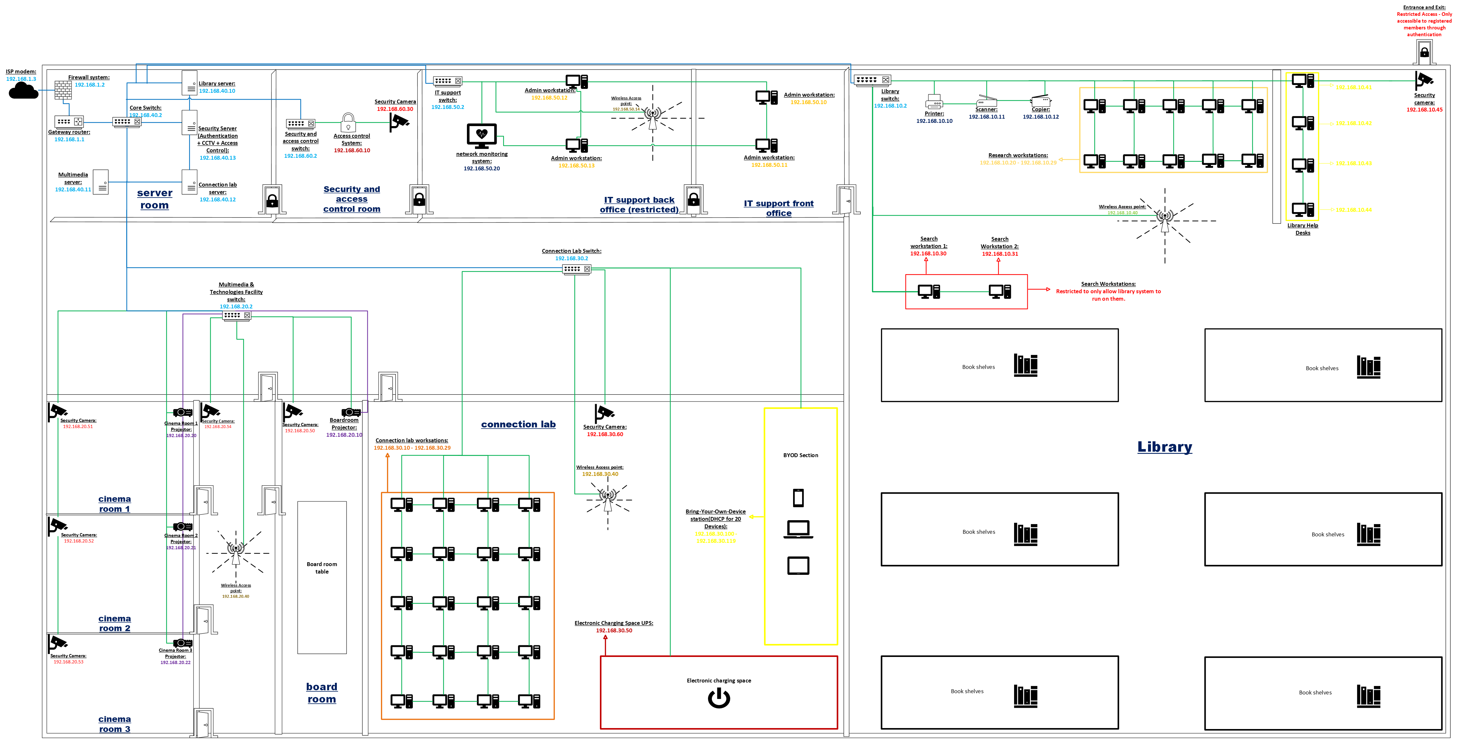

**\*NOTE* Please see the attached photo uploaded separately in the comments on ARC for the network diagram document, in case the image displayed above is not clear.**

**Legend/Keys:**

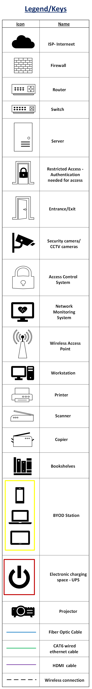

**Narrative for the Physical Network Diagram of Johannesburg’s “Library and Multimedia Technologies Center” (site 1):**

The network diagram shows how everything is connected at Johannesburg’s “Library and Multimedia Technologies Center” (site 1), ensuring the setup is organized, secure, and runs smoothly. The layout follows best practices for managing devices, cabling, and wireless access, all while keeping the network scalable and secure for future expansion.

**Internet Connection:**

The ISP connection links to a firewall system for extra security. From there, the gateway router (192.168.1.1) handles incoming and outgoing traffic, making sure the internal network stays connected to the internet.

**Main Network Devices:**

A core switch (192.168.40.2) connects all the important parts of the network, ensuring fast and stable communication between different departments. Each department, including the library, connection lab, multimedia center, IT support office, and Security and access control room, has its own switch to manage traffic within their department.

**Servers:**

* Security Server (192.168.40.13): Manages access control and CCTV systems.
* Library Server (192.168.40.10): Handles library workstations and the library management system.
* Multimedia Server (192.168.40.11): Stores and shares media content used in the cinema rooms.
* Connection labs server (192.168.40.12): Manages network access and services for the lab, ensuring members can connect to shared files and software.

**Devices & Workstations:**

Each department has its own workstations which are all connected to their local switches with their assigned IP addresses.

**Cabling & Wireless Setup:**

* CAT6 cables are used for all wired connections, making sure the network is fast and stable.
* Fiber optic cables are used for high-speed backbone connections, ensuring fast and reliable data transfer.
* HDMI cables are used to connect projectors for presentations and multimedia use.
* Wireless Access Points are placed in specific areas to provide Wi-Fi coverage.
* Security cameras and access control systems are wired directly to switches to keep them secure and reliable.

**Security & Access Control**

* Security cameras are placed in important areas like the Library, Cinema Rooms, and IT Support Offices for surveillance.
* The access control system (192.168.60.10) restricts entry to certain areas, allowing only authorized users.
* Firewalls help keep the network secure and organized.

**My Assumptions**

* The network is designed to be scalable, so more devices can be added in the future without causing issues.
* My design follows best practices, ensuring proper cable management, device placement, and security.

The physical network diagram for Johannesburg's “Library and Multimedia Technologies Center” ensures secure and smooth connectivity across all departments. By combining both wired and wireless connections, with a focus on security and organization, the network is designed to meet current needs while supporting future growth. This setup provides a reliable network for both staff and members.

# Activity 5 Capstone projects and reflection report

**Capstone Projects**

#### Project 1-1: set up a windows virtual Machine using Hyper-v:

* Virtual Machines were created using Hyper-V. (Microsoft, 2024)

**Screenshot of VM settings:**

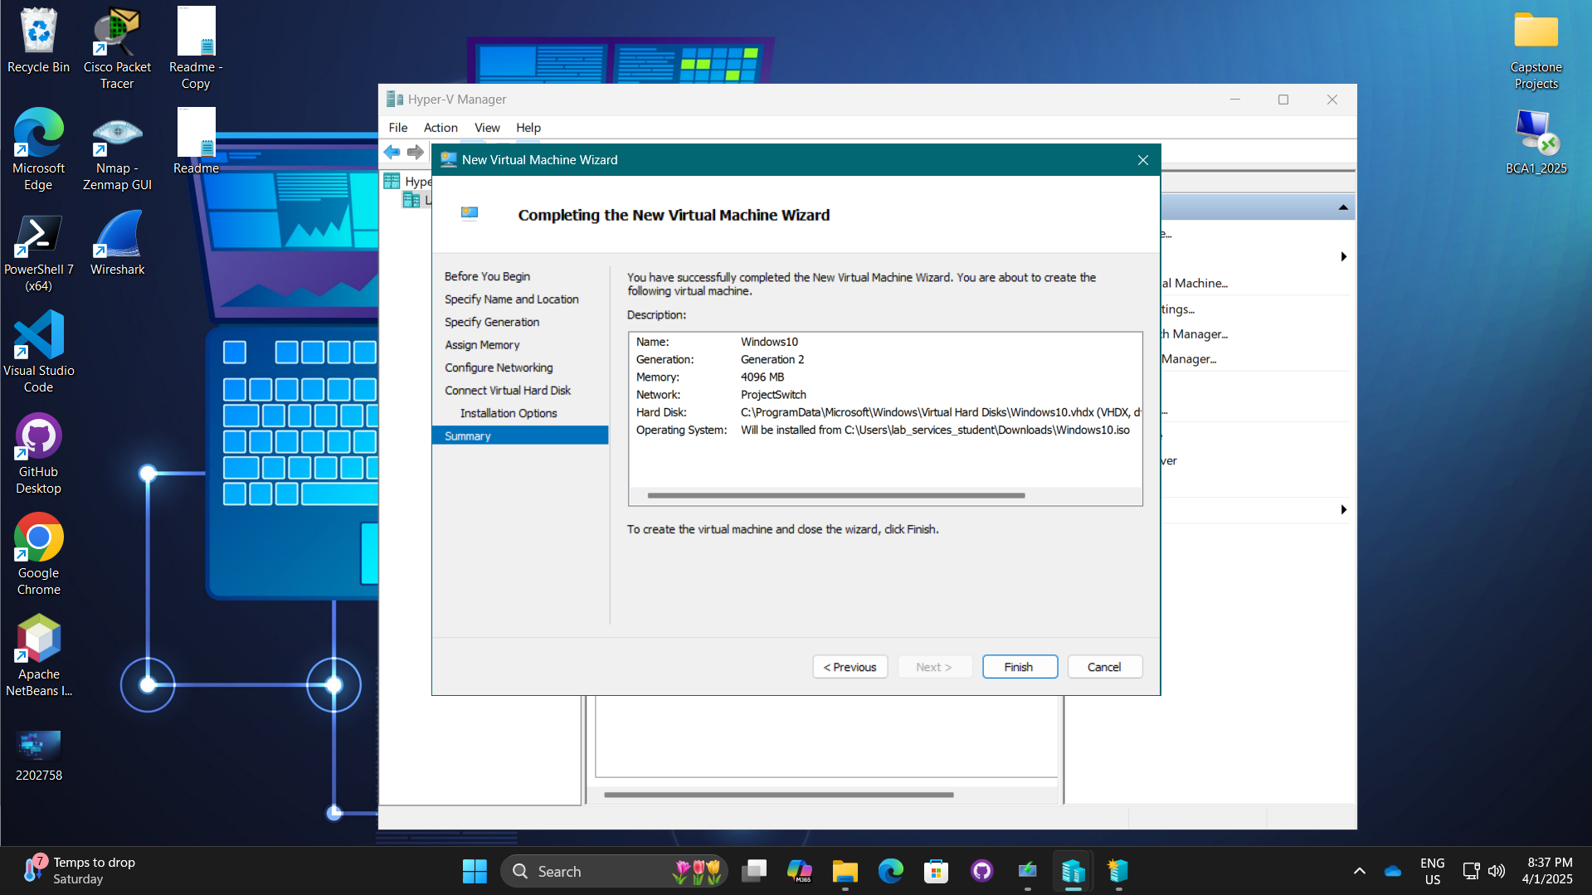

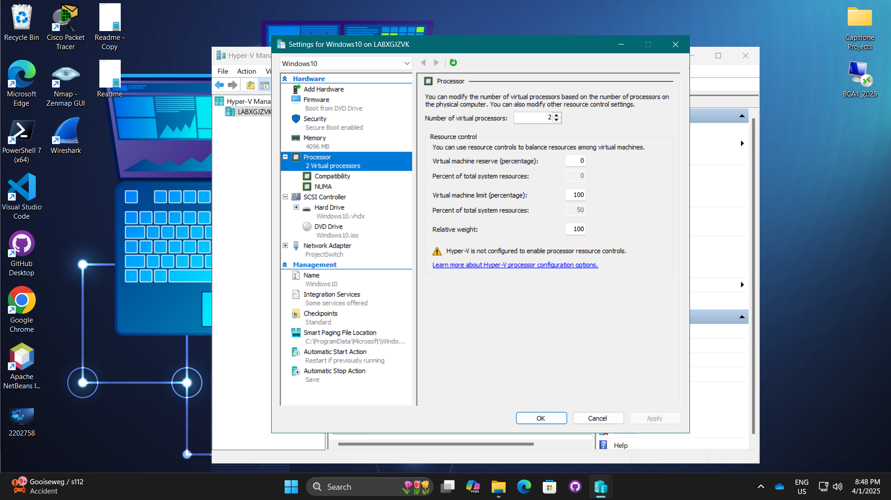

**How much memory will the VM have?**

* 4096 MB

**How many virtual processors will the VM have?**

* 2

**What device will the VM boot from?**

* From DVD drive

**Screenshot of desktop showing Hyper-V Manager, running VM, and VM’s successful connection with the Internet:**

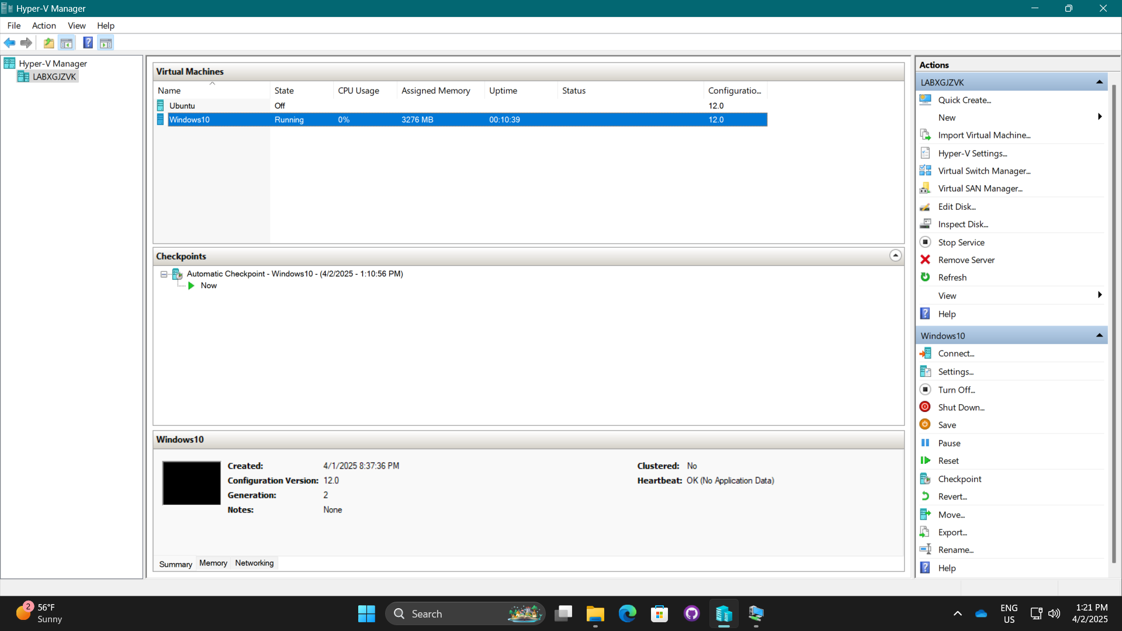

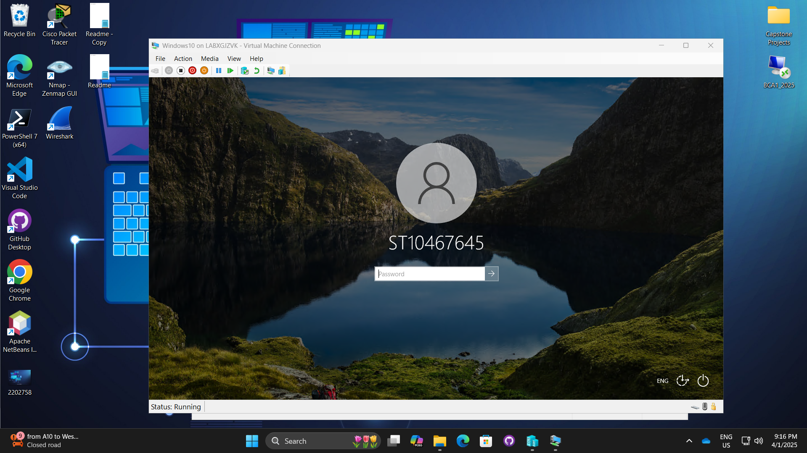

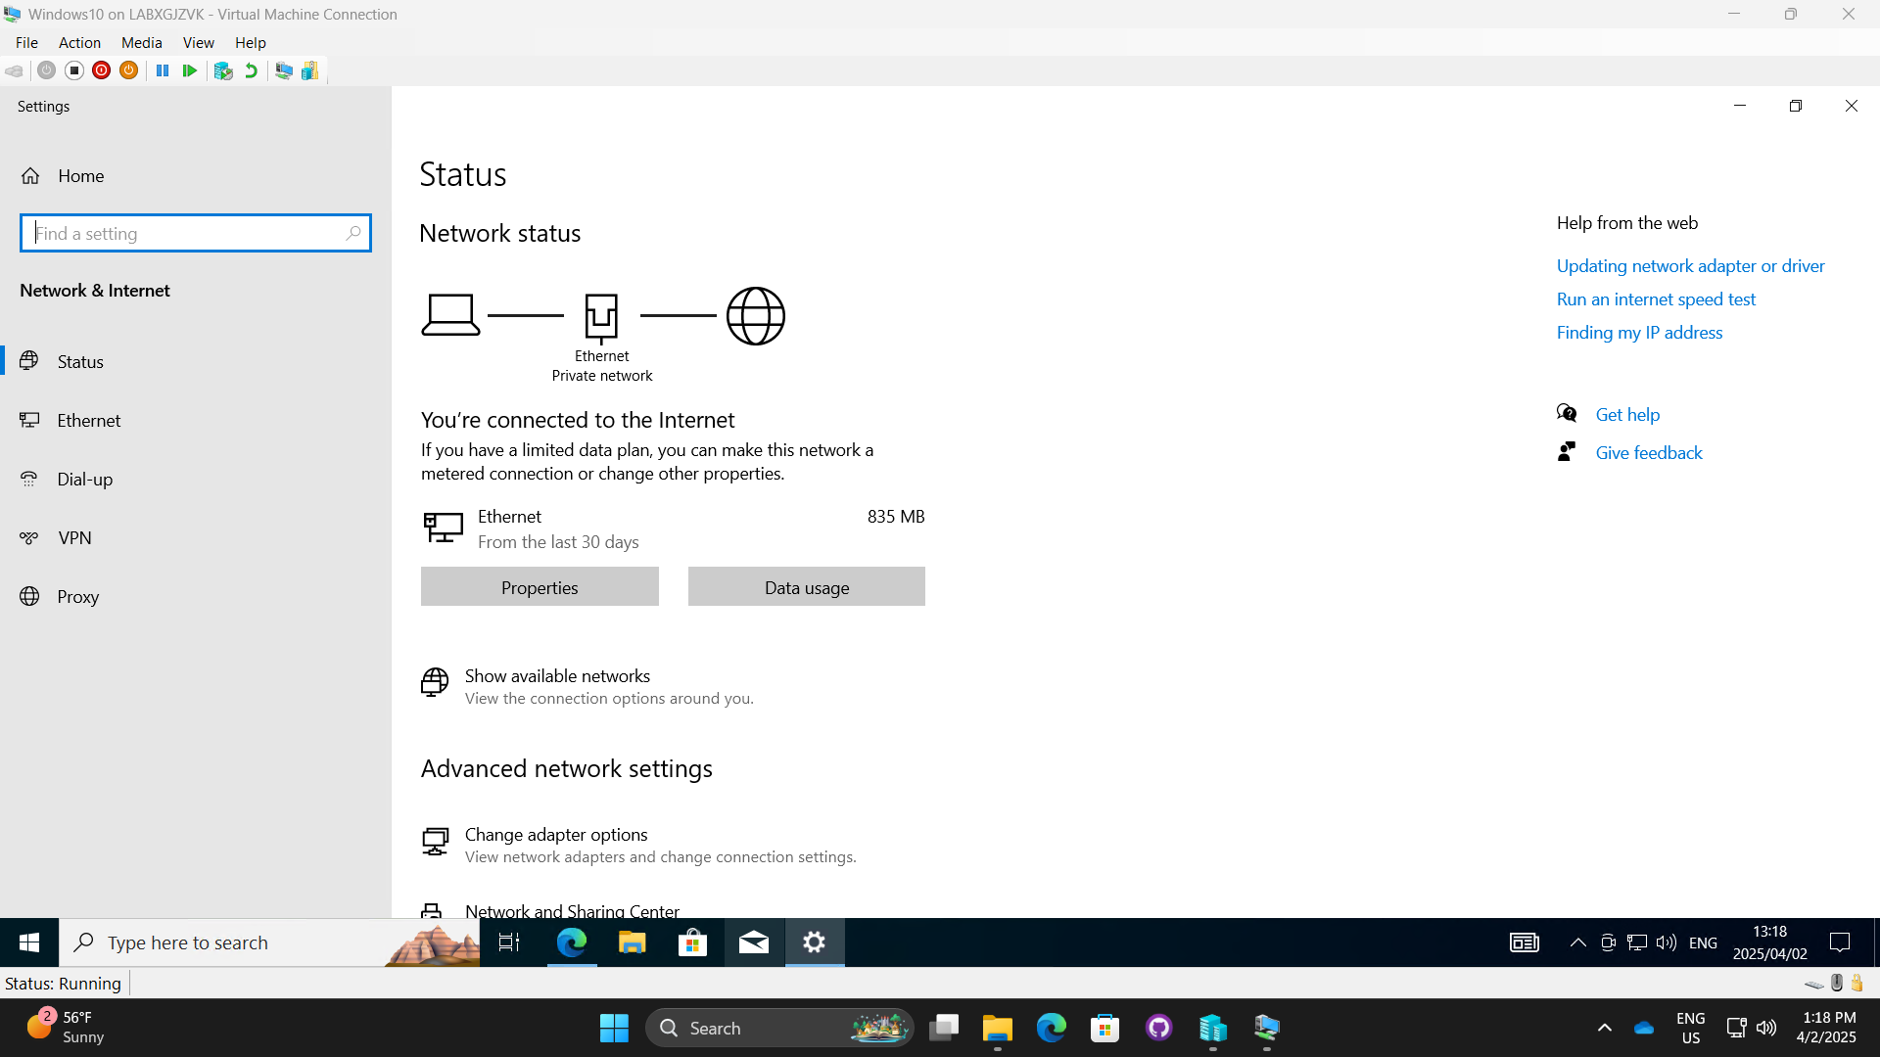

#### Project 2-3 Install and use Nmap and Zenmap:

* The network scan was done using Nmap with the Zenmap GUI. (Gordon Lyon, 2023)

**Screenshot of Nmap-Zenmap GUI shortcut:**

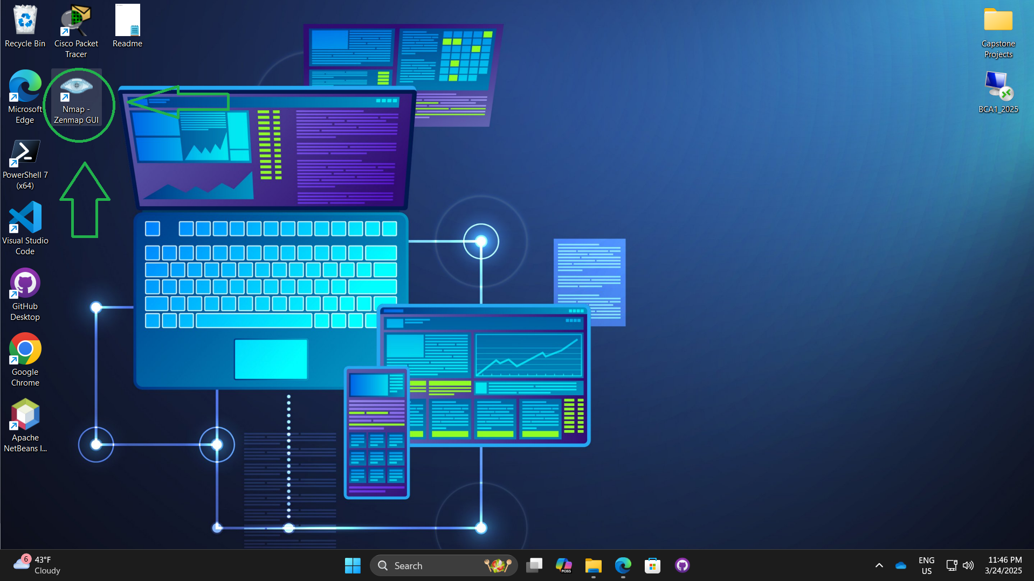

**Screenshot of localhost scan results:**

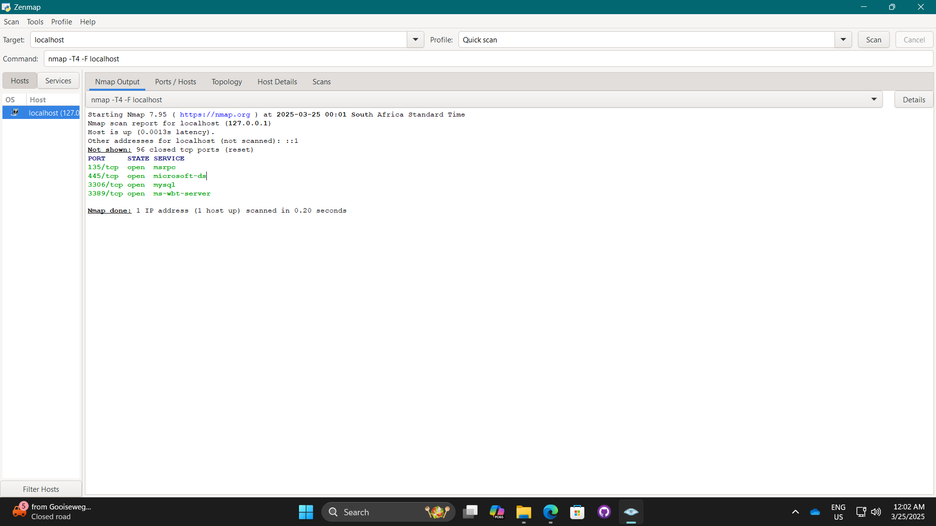

**Screenshot of open ports on a scanned host**

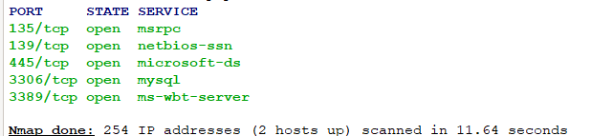

**Screenshot of nmap command, regular scan command, and results:**

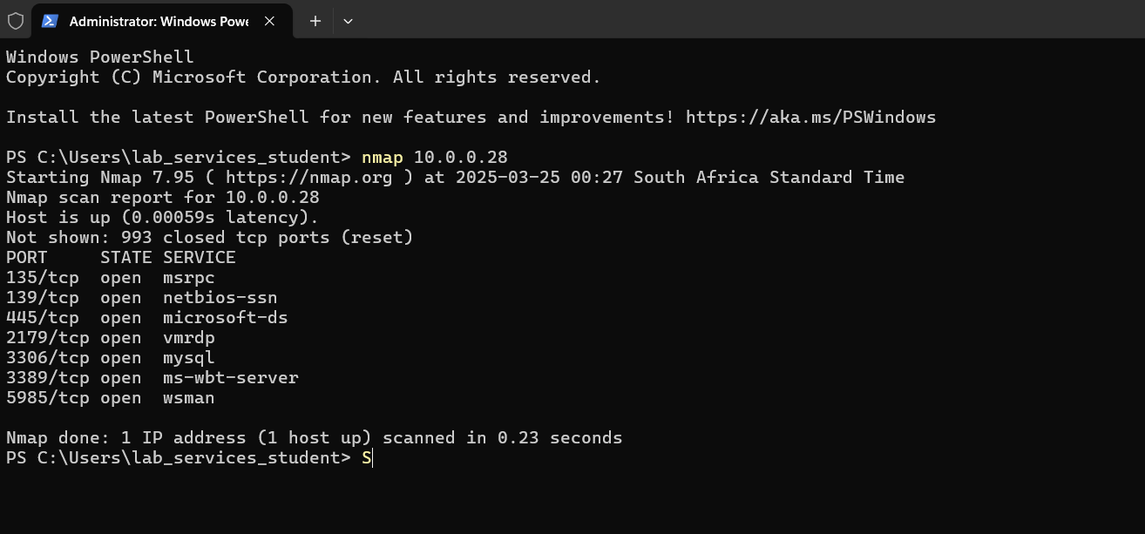

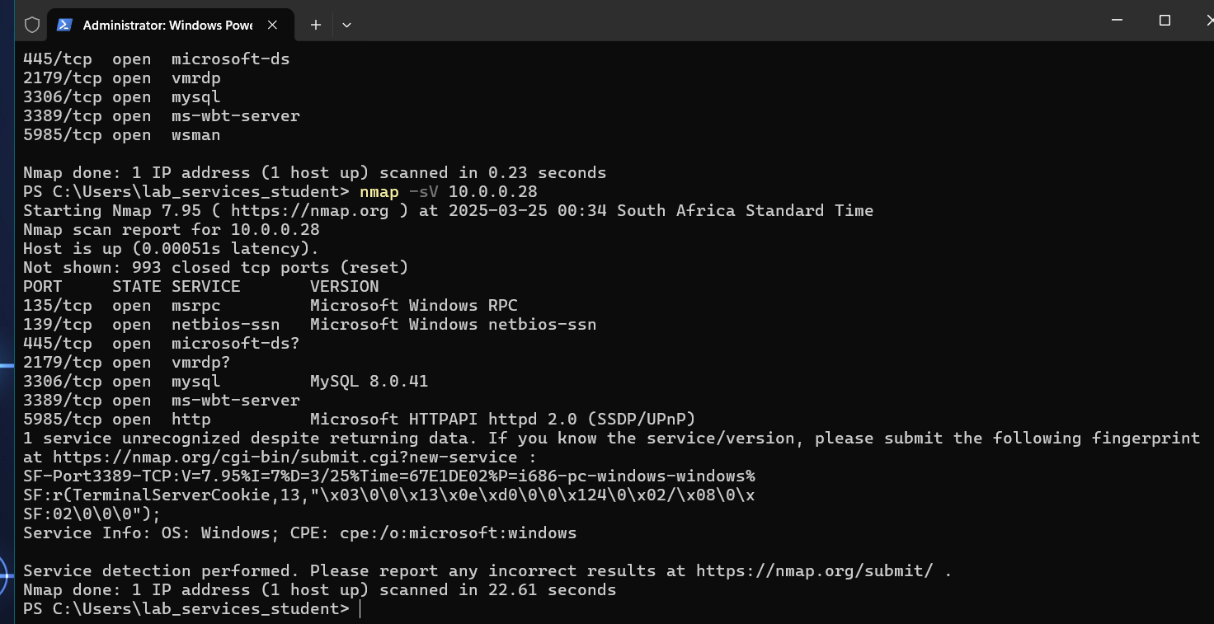

**Screenshot of Wiki dot page about Nmap with the questions and answers**

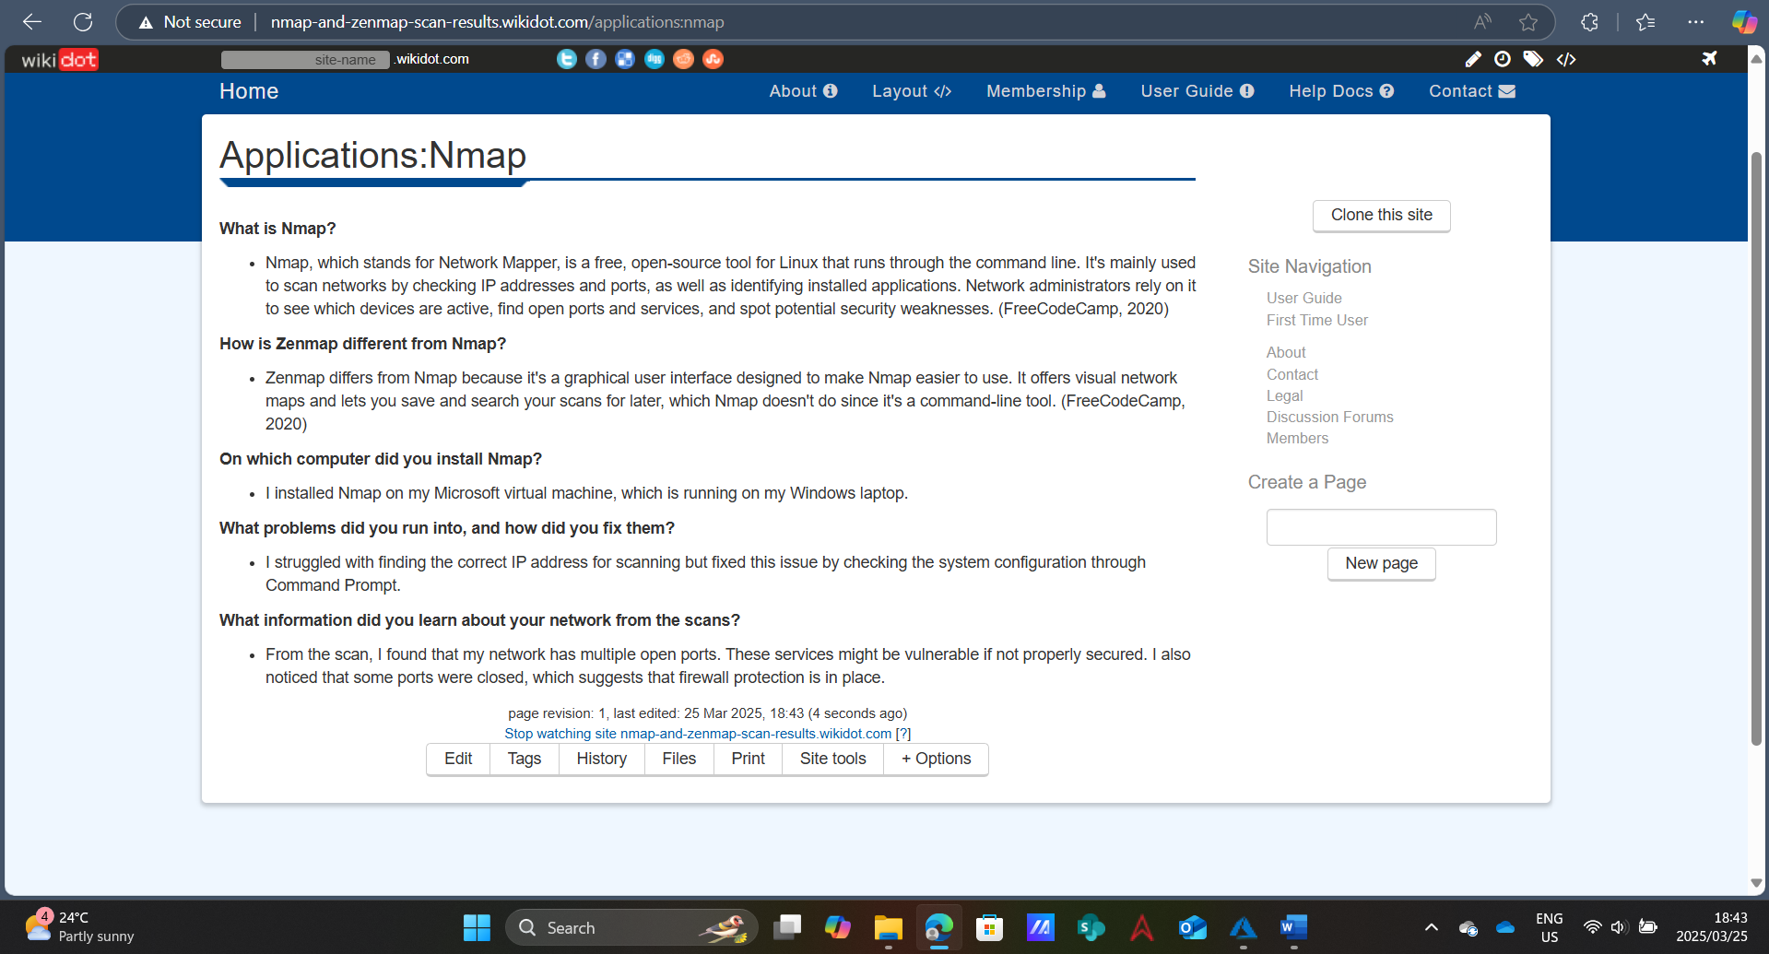(FreeCodeCamp, 2020)

#### Project 2-4: Install and use Wireshark:

* **Wireshark was used to capture packets.** (Wireshark Foundation, 2023)

**Screenshot of the Wireshark capture with a UDP message selected:**

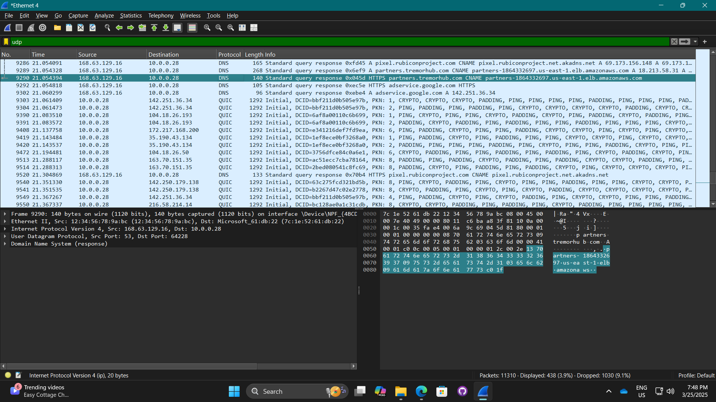

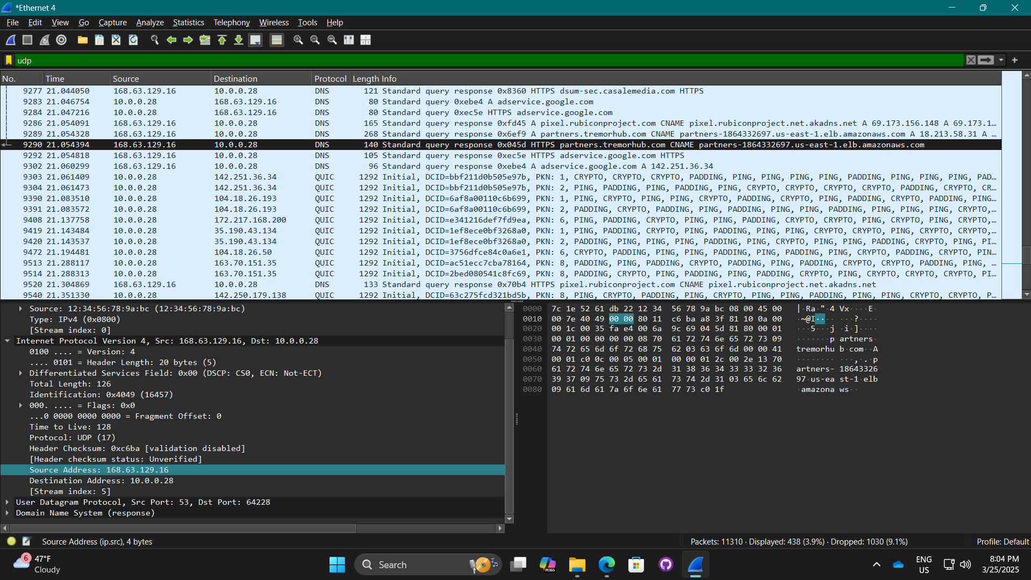



**What information stands out?**

* All the numbers and letters on the bottom right

**Who sent this message?**

* Source Address: 168.63.129.16

**Who received it?**

* Destination Address: 10.0.0.28

**Colouring rules:**

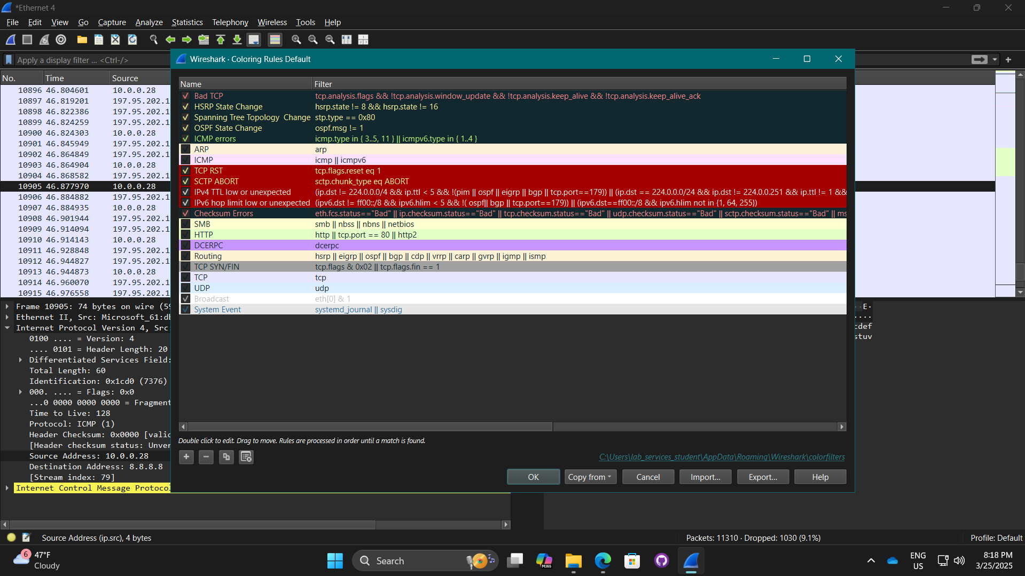

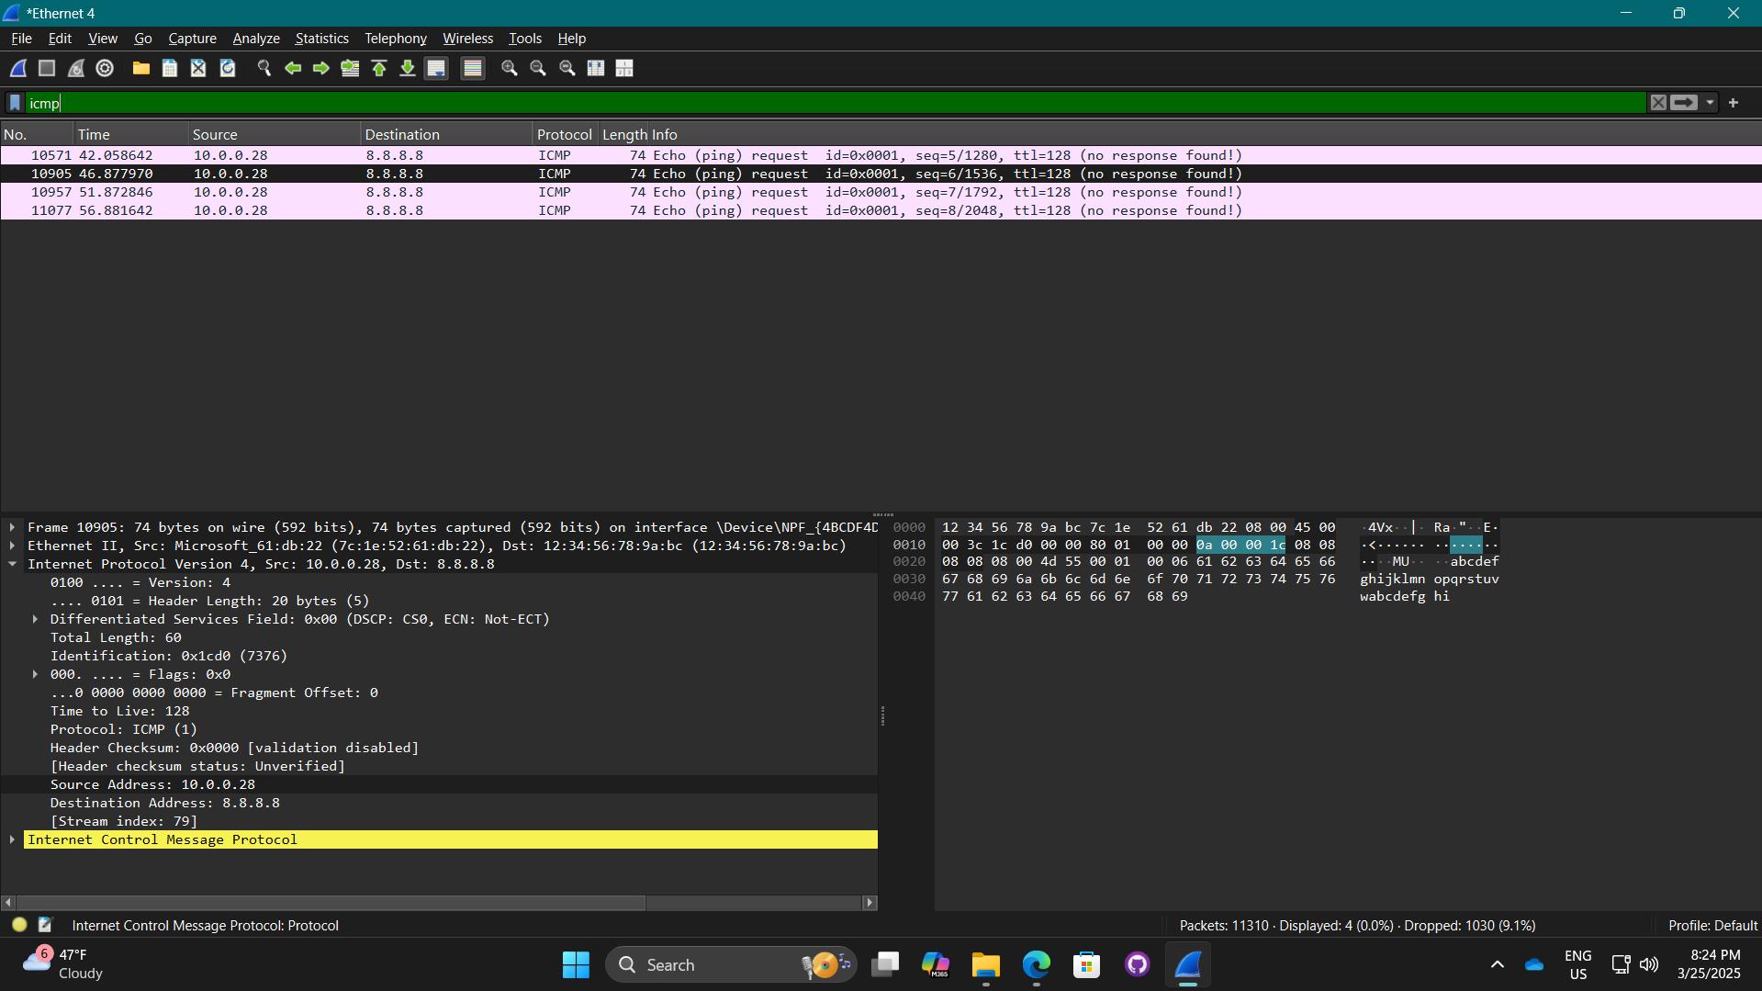

**Which protocols did you find?**

* ICMP

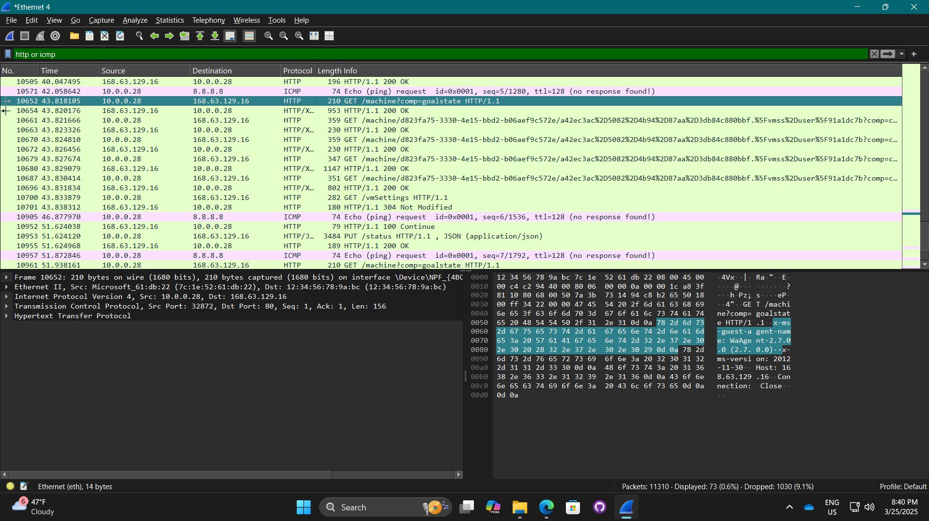

**Examine the HTTP message**

* This HTTP message relies on TCP at the transport layer and IP at the network layer to reach a web server.

**TCP stream:**

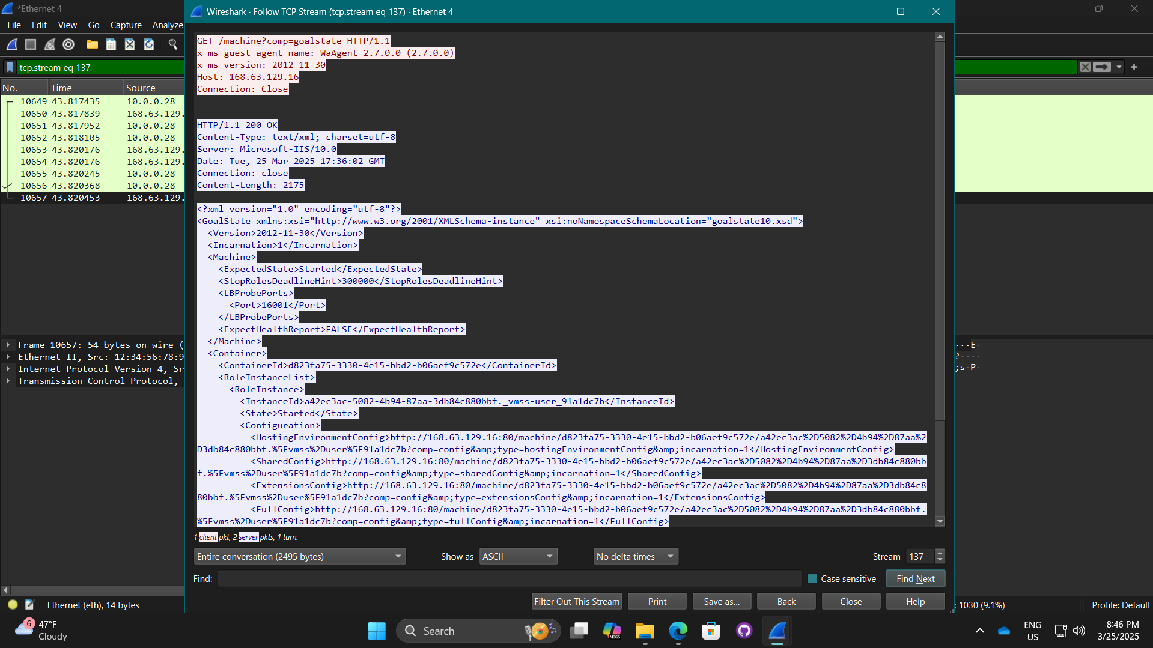

**TCP stream after clicking close**

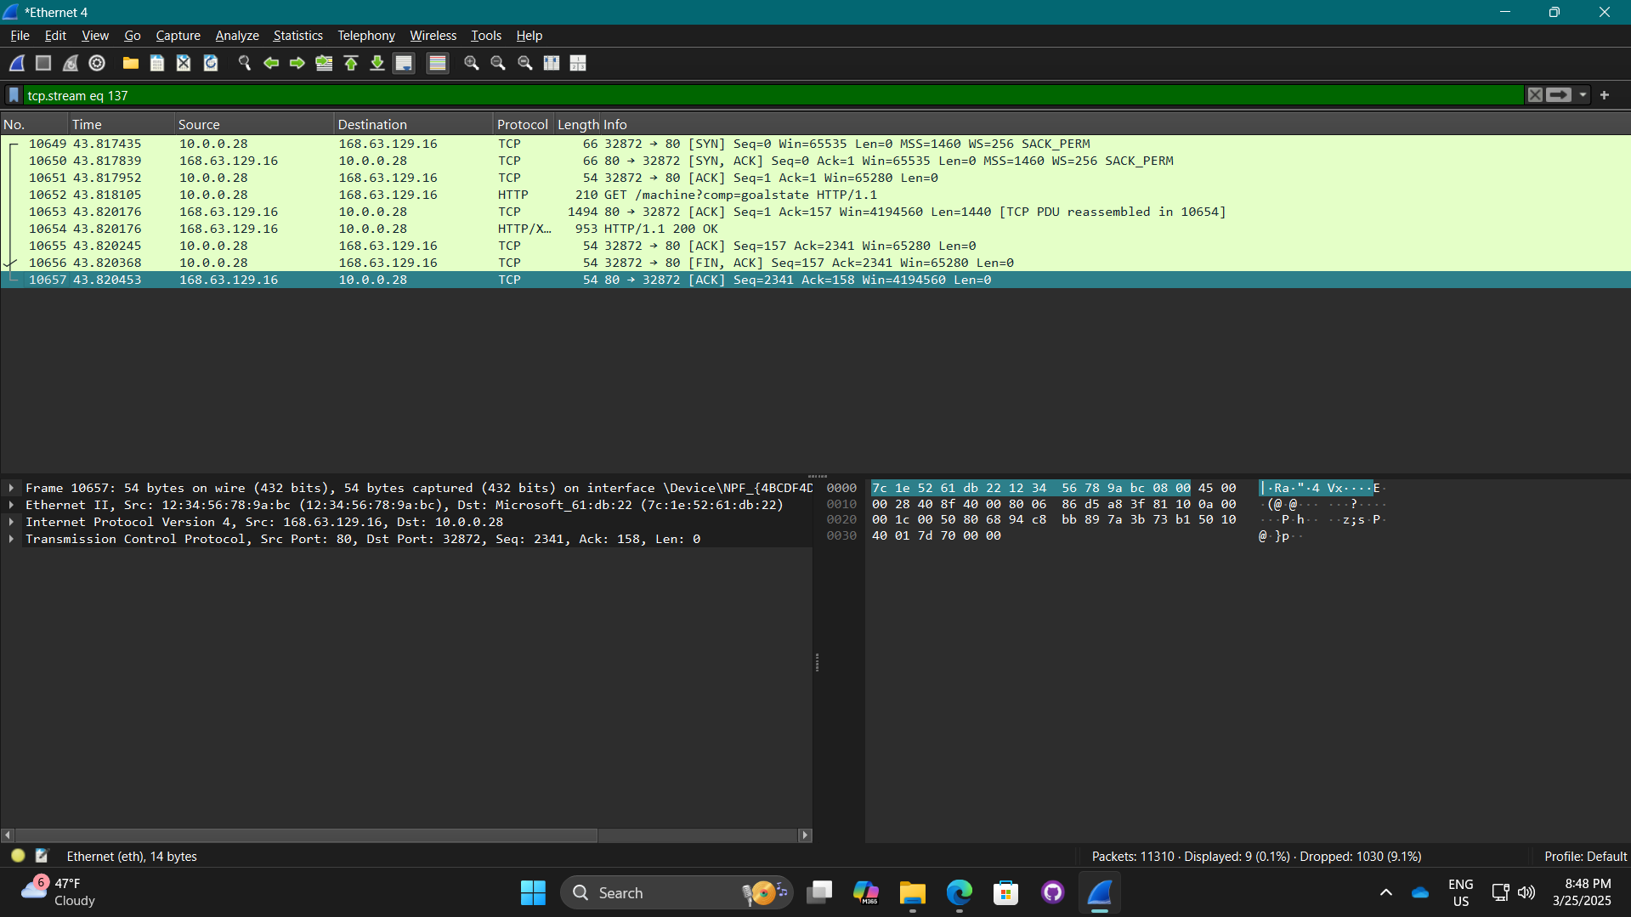

**Screenshot of Wiki dot page about Wireshark with the questions and answers**

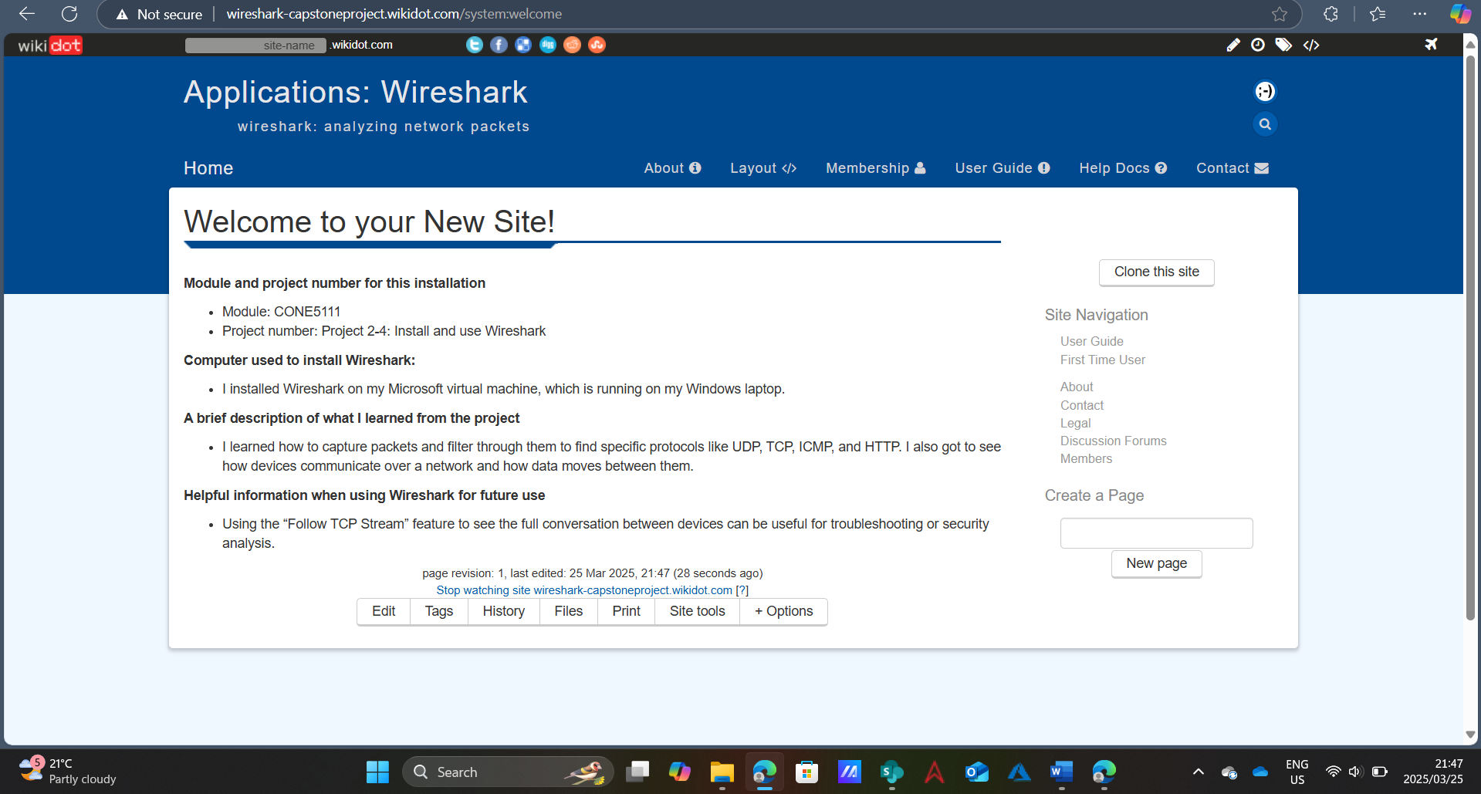

#### Capstone Project 2-1: Set up an Ubuntu VM:

* Virtual Machines were created using Hyper-V. (Microsoft, 2024)

**Screenshot of desktop showing hypervisor, running VM, and VM’s successful connection with the Internet:**

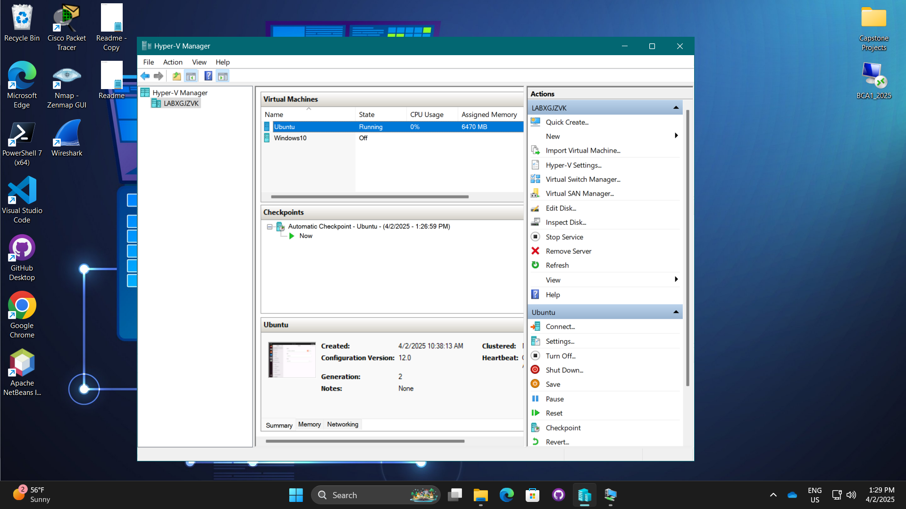

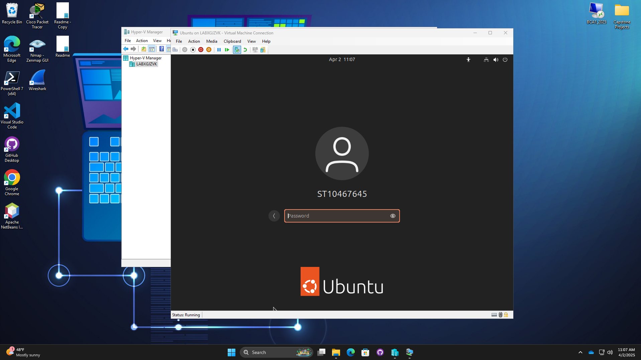

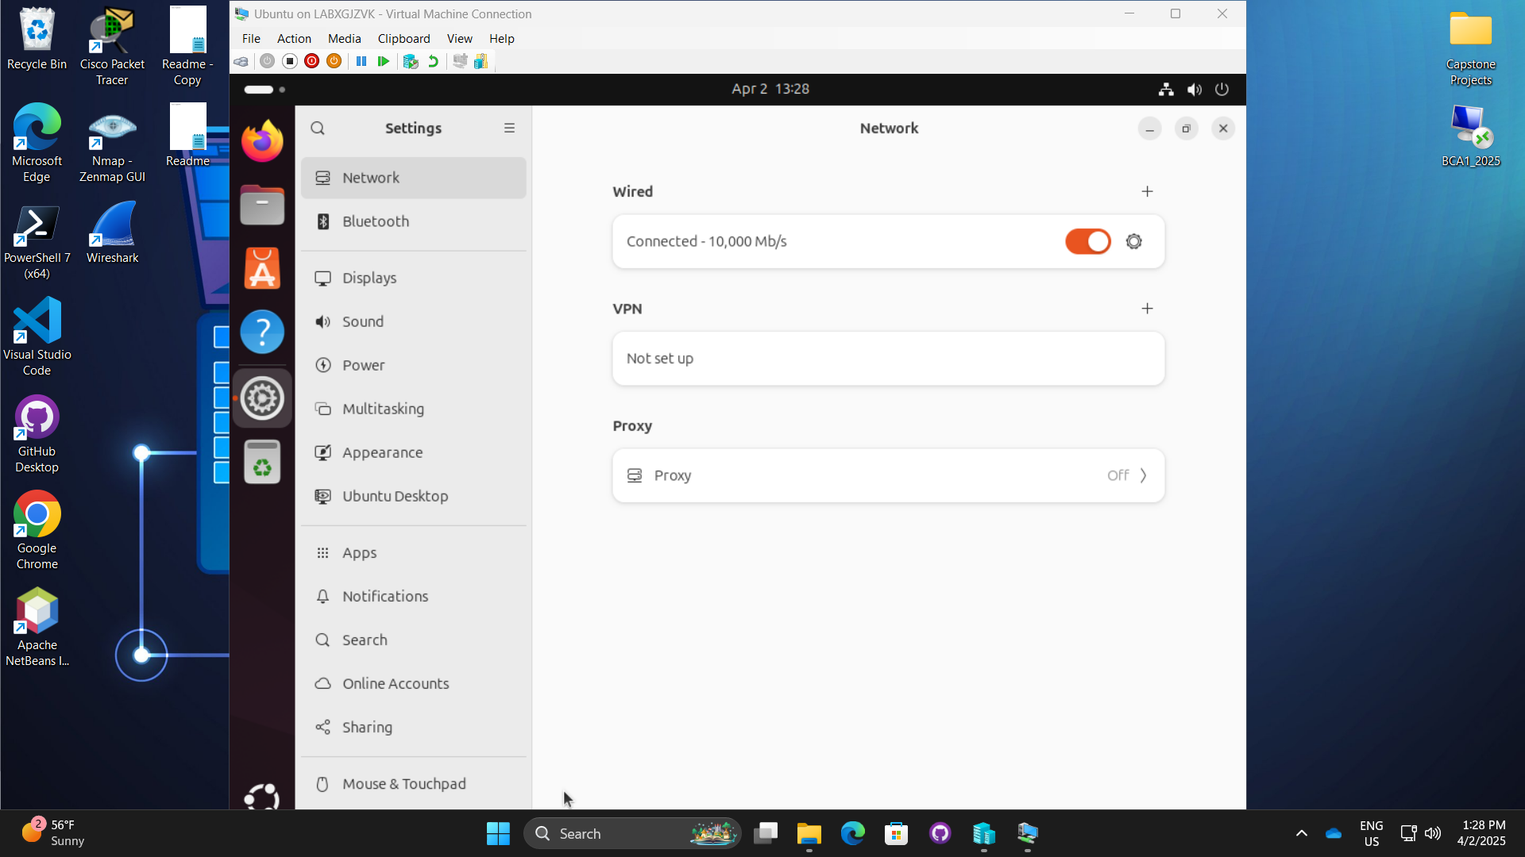

**What are two ways to open the Settings window in Ubuntu Desktop?**

* In the bottom left corner, select “Show Apps” then choose settings.
* Click the option in the top right corner to open a dropdown menu then select settings from the left side of the box.

**Screenshot of Wikidot website with added file and notes:**

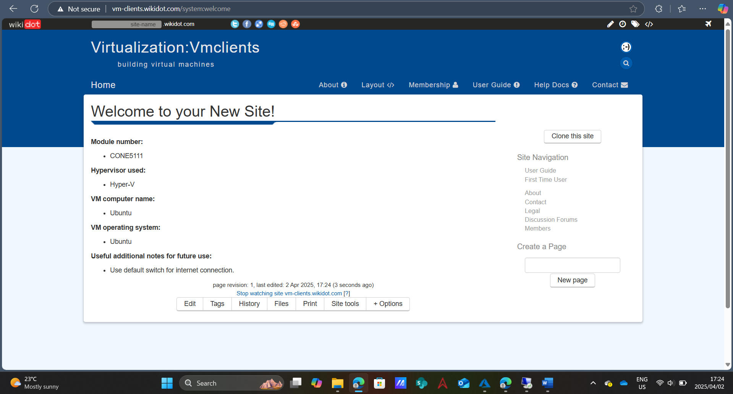

#### Capstone Project 2-1: Install and use Packet Tracer:

* The interface layout was created using Cisco Packet Tracer. (Cisco Networking Academy, 2024)

**Screenshot of the Packet Tracer window showing the interface layout:**

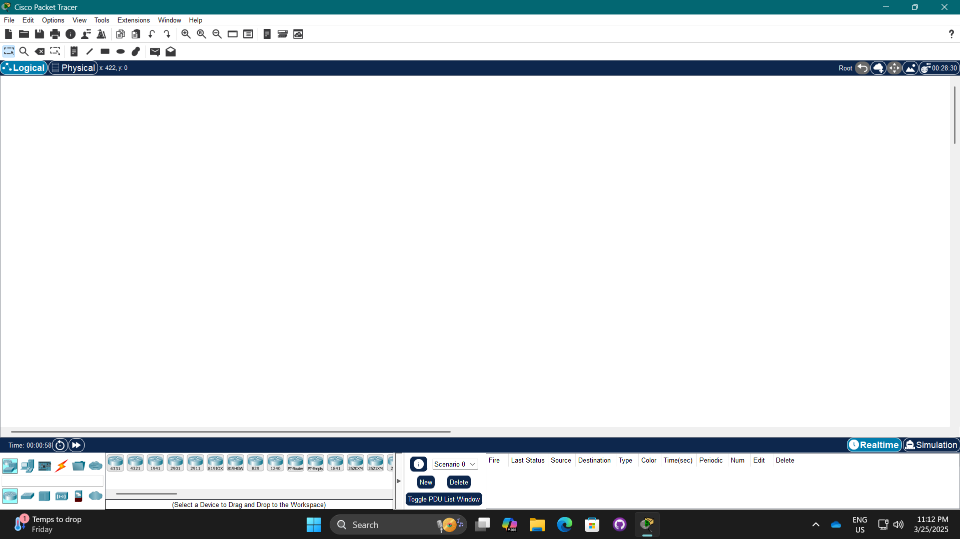

**What is the first step in deploying a Packet Tracer network?**

* The first thing you should do when deploying a Packet Tracer network is start a new project, then add devices and configure them. (netacad, n.d.)

**When looking at a physical device’s tabs in Packet Tracer, which tab is considered the learning tab?**

* The physical tab is considered the learning tab. (netacad, n.d.)

**What three questions can be answered using the Simulation Mode?**

* What is the status of the network devices while communication is taking place? (netacad, n.d.)
* How is the data being processed as it moves across the network? (netacad, n.d.)
* In what way do the devices communicate with one another? (netacad, n.d.)

**Which Packet Tracer feature do you think will be most helpful for you in learning how to manage a network? Why do you think this?**

* The most helpful packet tracer feature for me in learning how to manage a network would be the simulation mode as it allows me to test whether my network setup works and functions before applying it.

**Screenshot of deployment:**

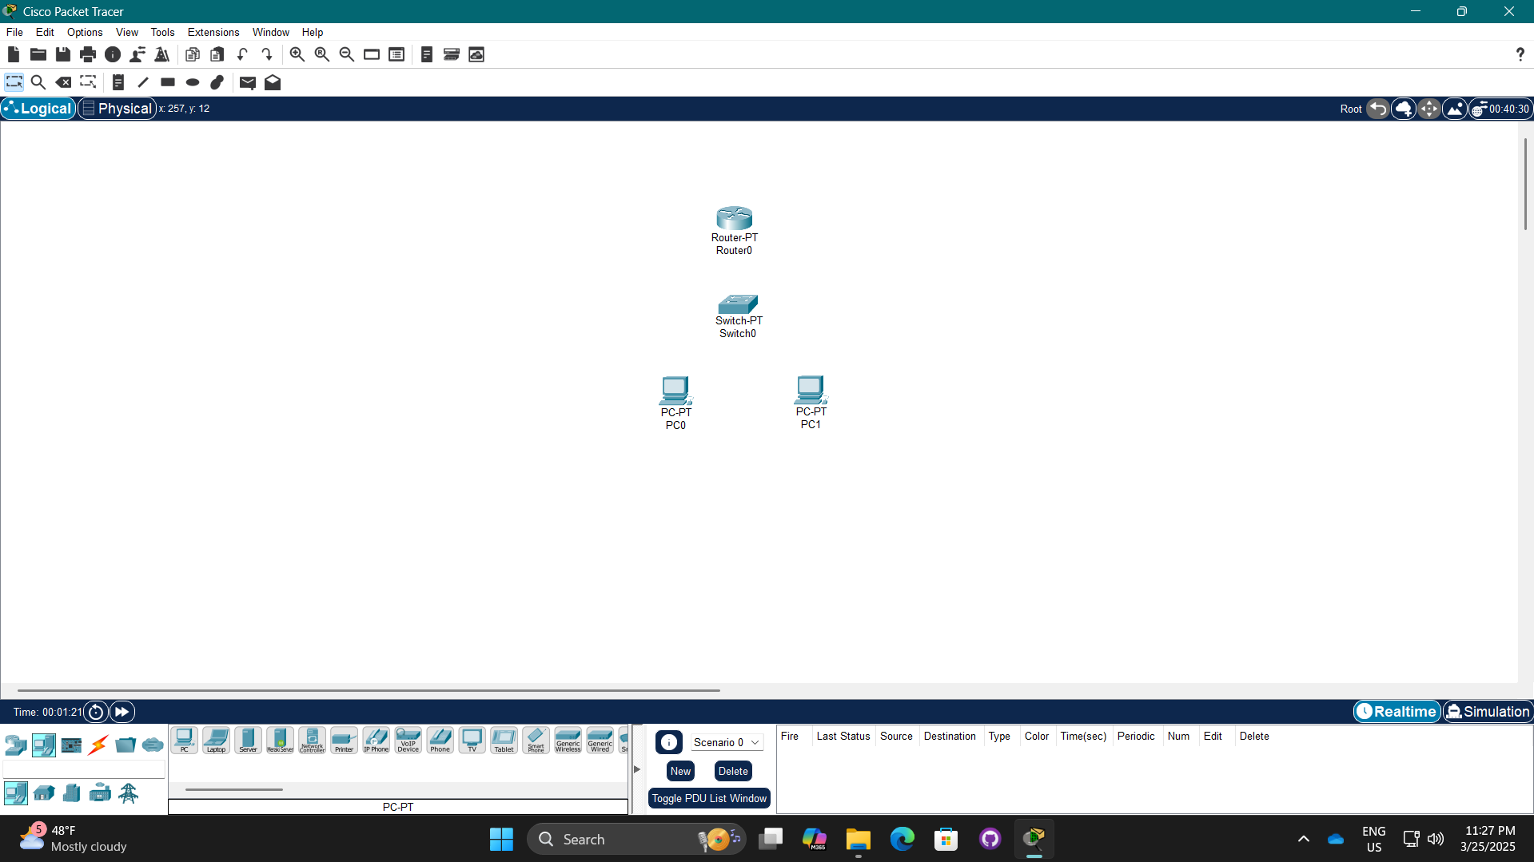

**Screenshot of Wiki dot page about Packet Tracer with questions and answers**

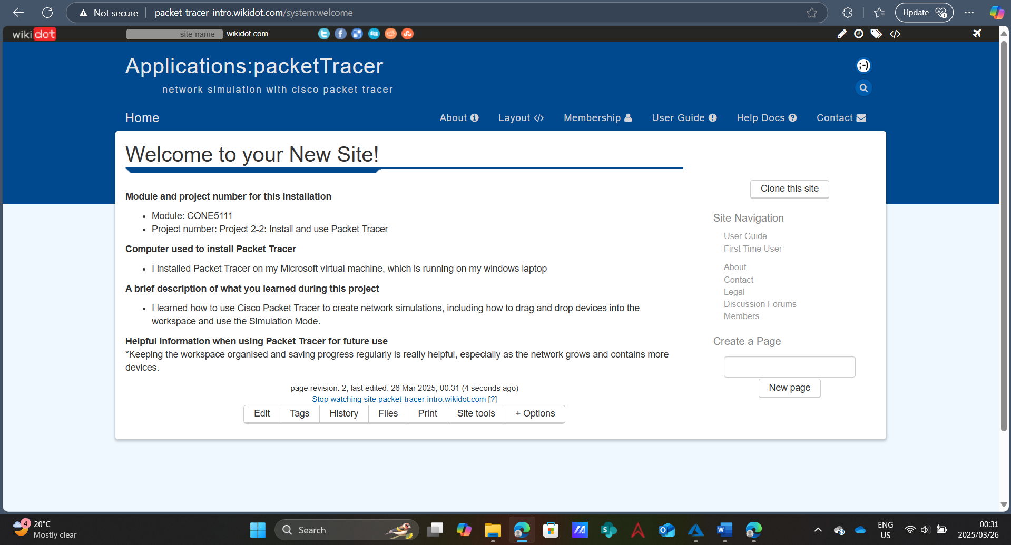

#### Capstone project 5-1: Decode a TCP Segment in a Wireshark Capture

* **Wireshark was used to capture packets.** (Wireshark Foundation, 2023)

**Screenshots of filtered DNS request:**

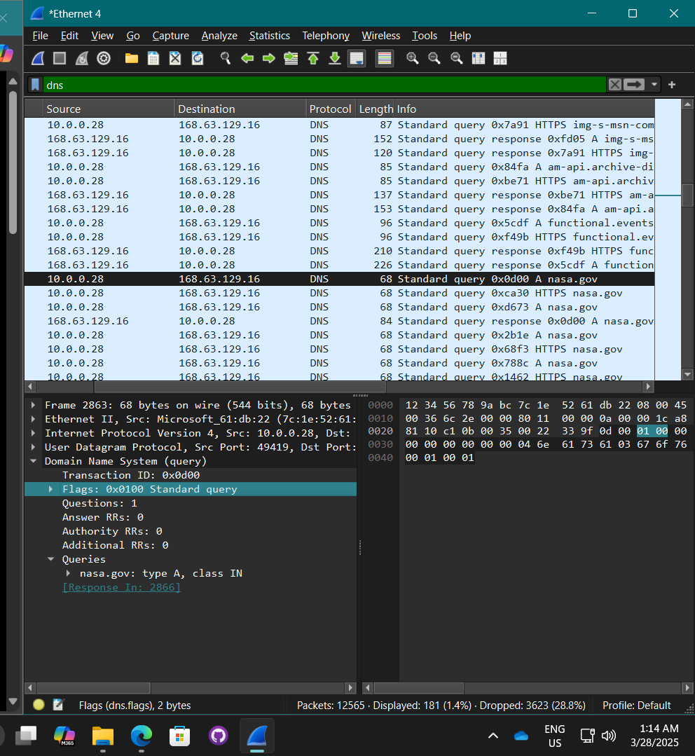

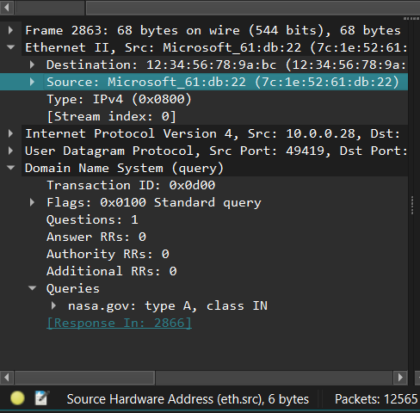

**What is the OUI of the source’s NIC?**

* 7C:1E:52

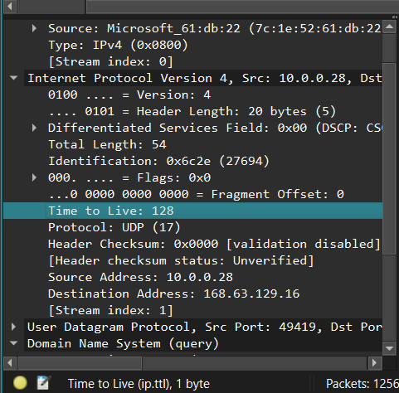

**Which IP version was used?**

* IPv4

**If the message used IPv4, what was the TTL? If IPv6, what was the hop limit?**

* 128

**Did the message use TCP or UDP?**

* UDP

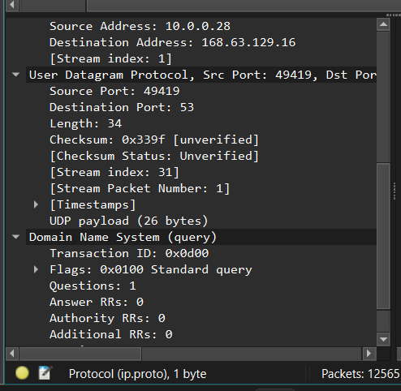

**What is the source port? The destination port?**

* Source port: 49419
* Destination port: 53

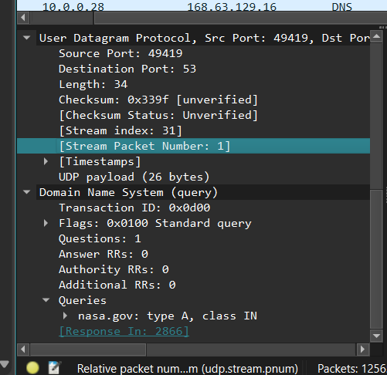

**What DNS record type is requested?**

* A

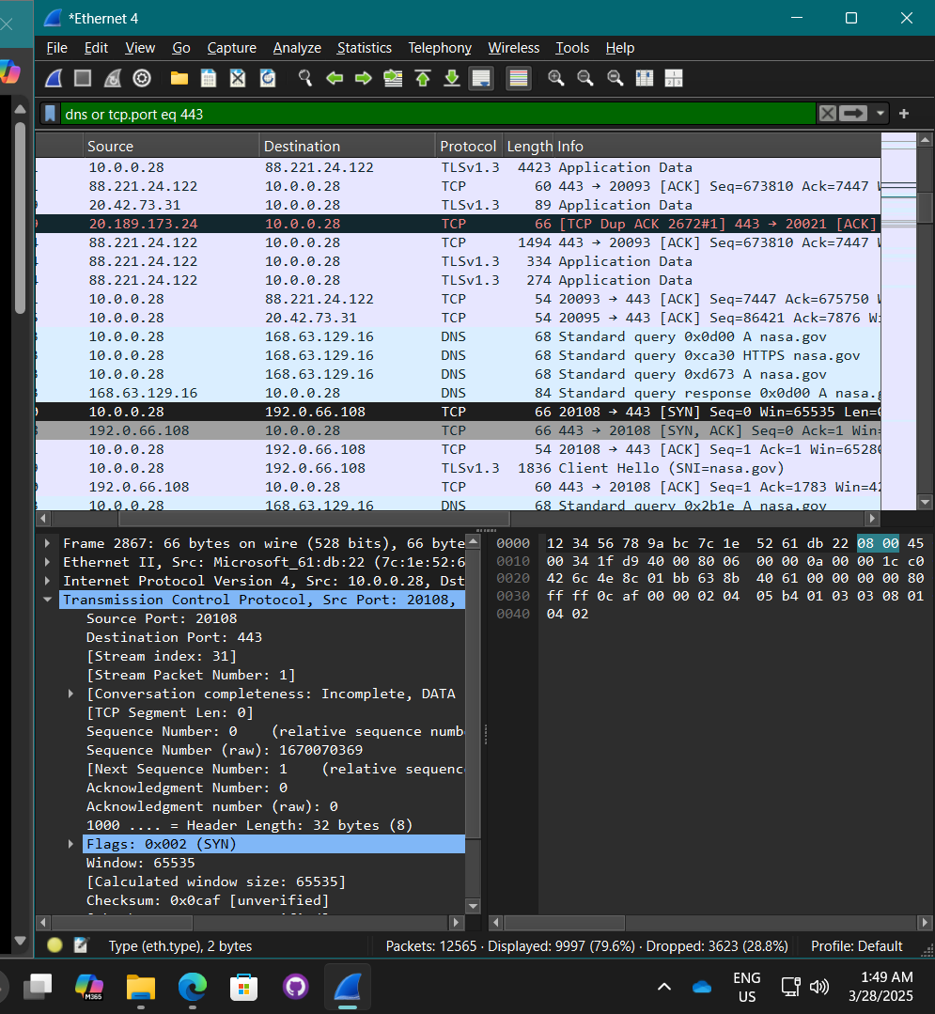

**Which flags are set in the TCP segment?**

* (SYN)

**Screenshot of TCP stream:**

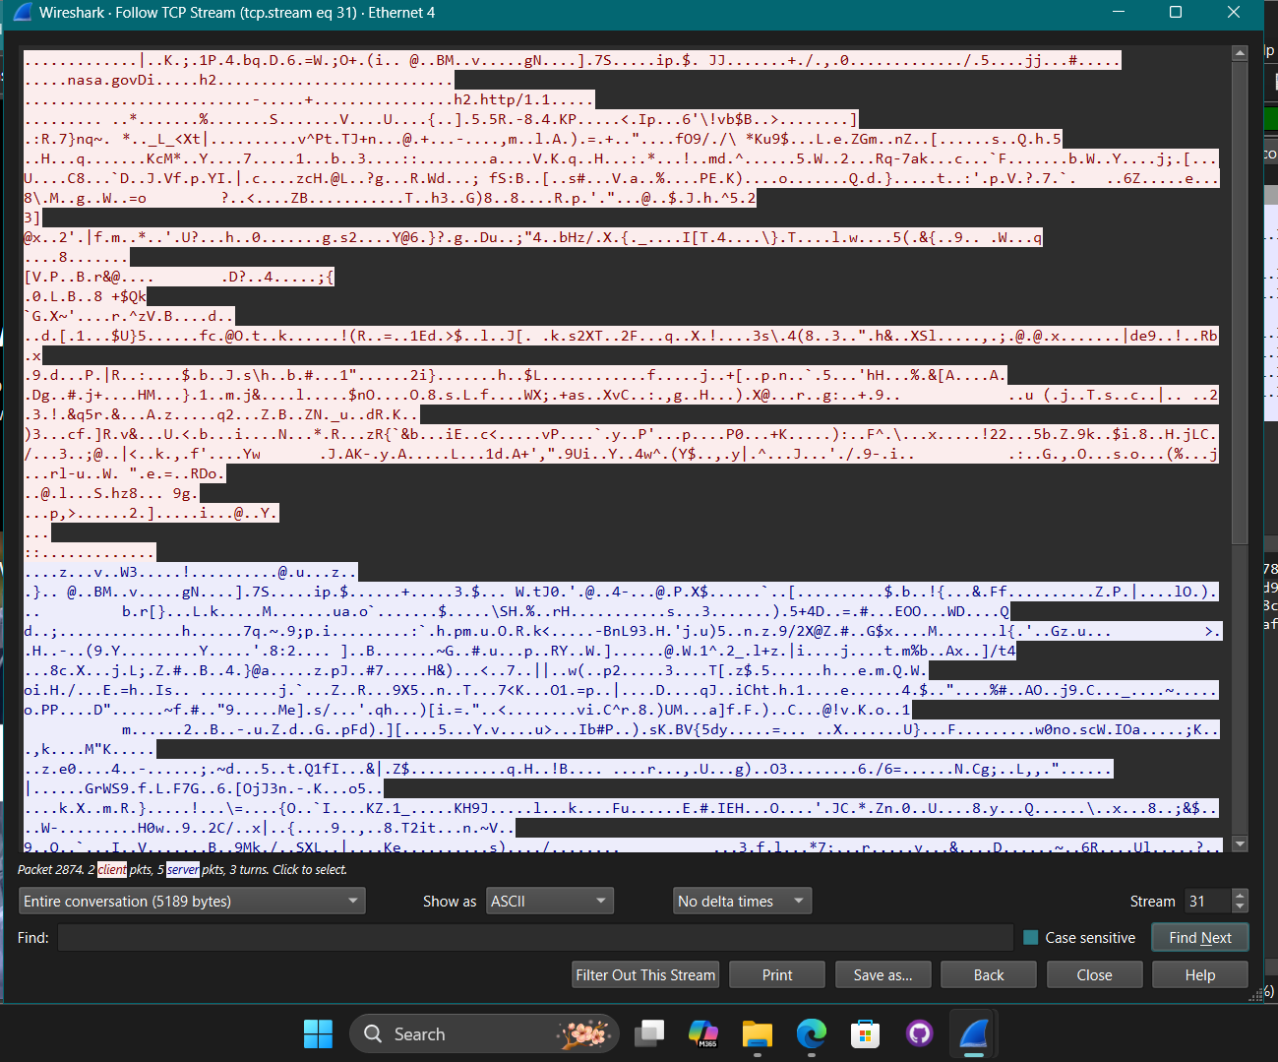

**Screenshot of [SYN, ACK] message:**

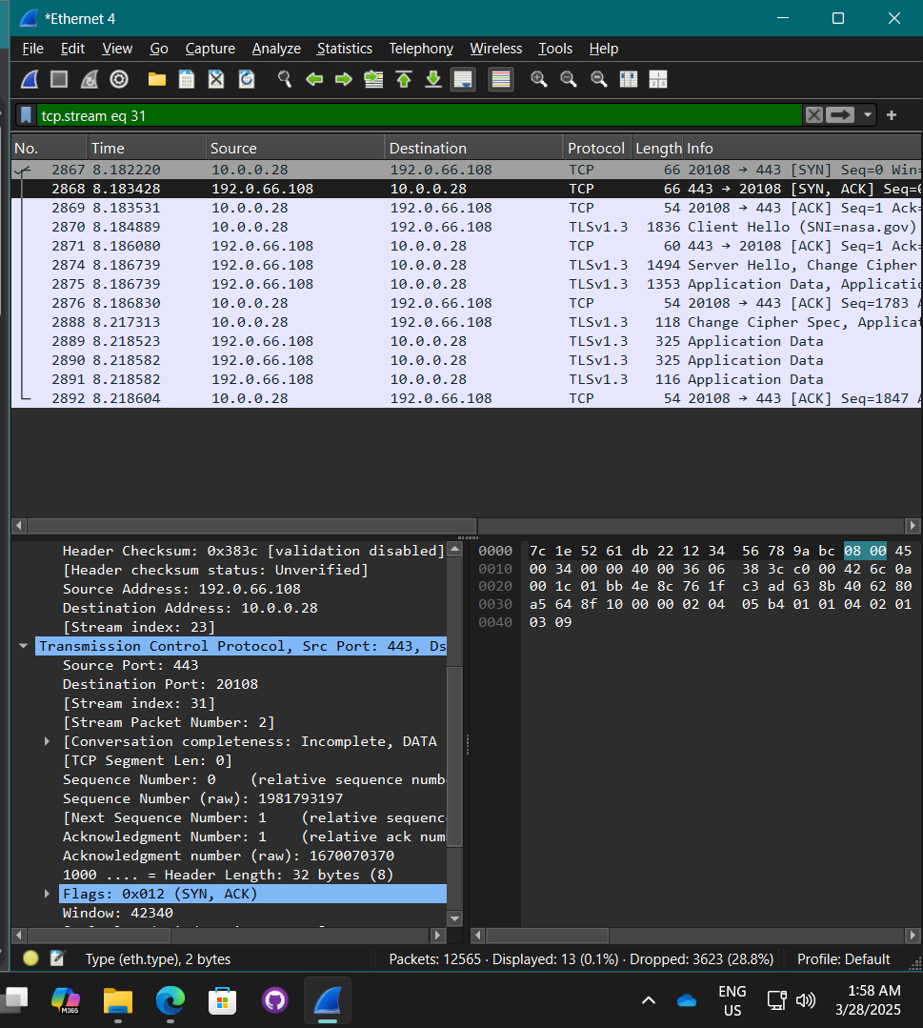

**What is the source IP address? The destination IP address?**

* Source IP address: 192.0.66.108
* Destination IP address: 10.0.0.28

**In the TCP header, what is the relative sequence number? The relative acknowledgment number?**

* Relative sequence number: 0
* Relative acknowledgment number: 1

**Which TCP Flags are set?**

* (SNY, ACK)

**Screenshot of [ACK] message:**

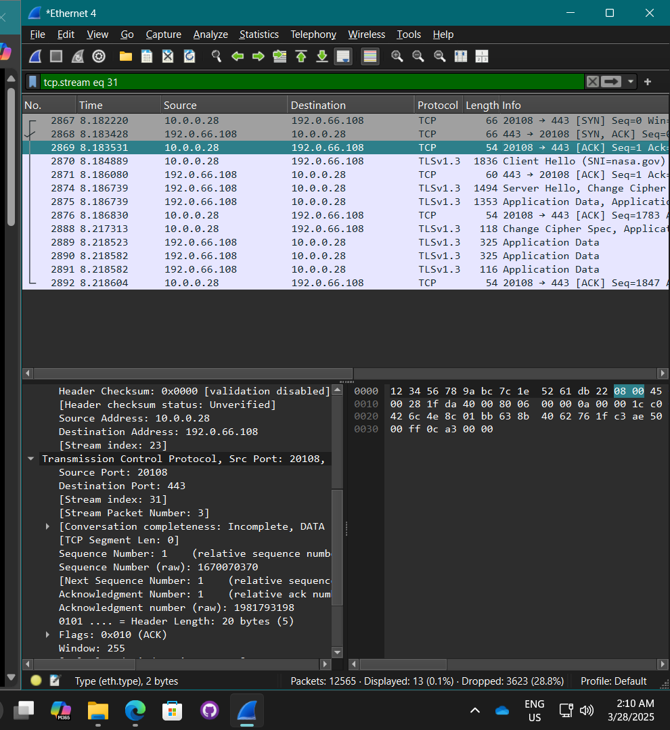

**What is the source IP address? The destination IP address?**

* Source IP address: 10.0.0.28
* Destination IP address: 192.0.66.108

**In the TCP header, what is the relative sequence number? The relative acknowledgment number?**

* Relative sequence number: 1
* Relative acknowledgment number: 1

**Which TCP Flags are set?**

* (ACK)

**Screenshot of capture showing the messages:**

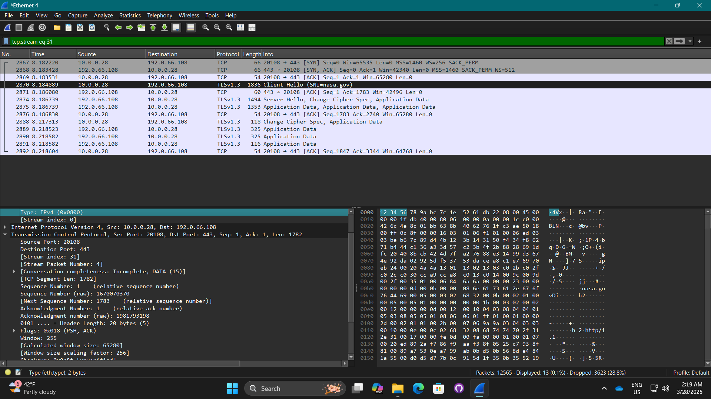

**Screenshot of longest message:**

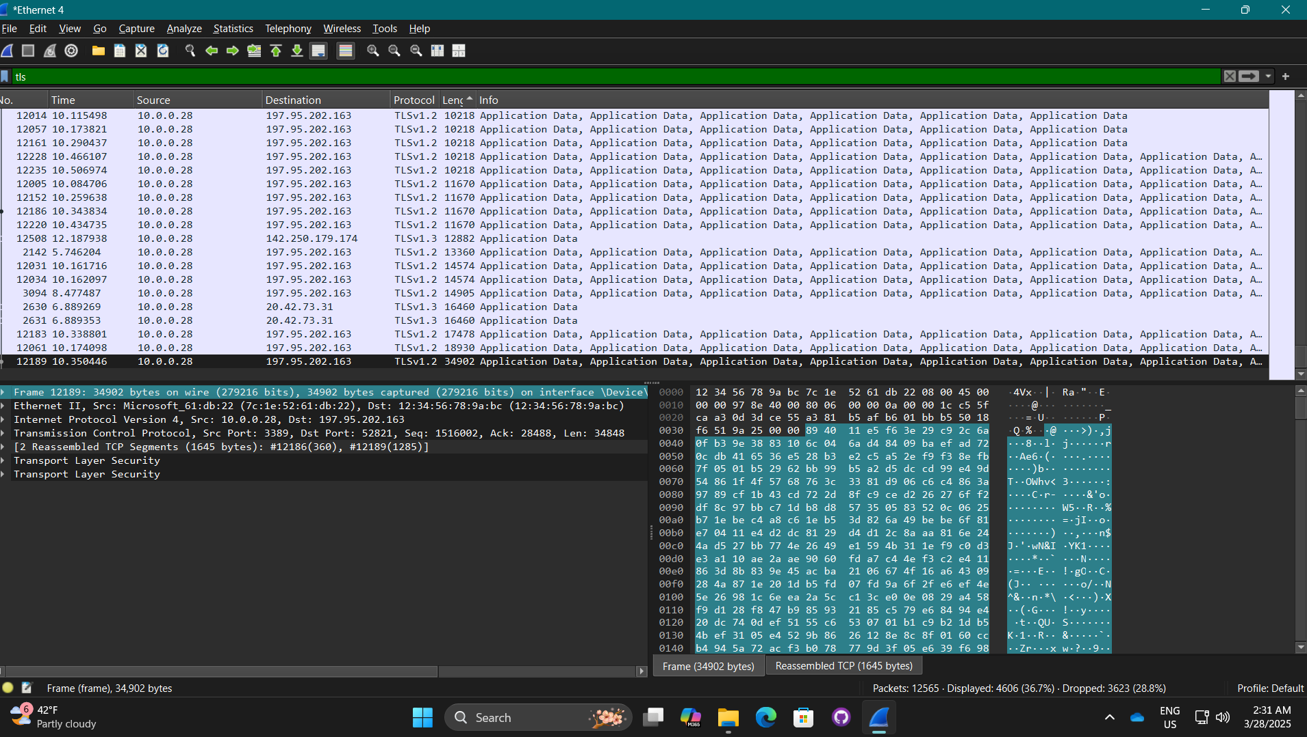

**What is the size of the longest message listed?**

* 34902 bytes

**List the types of headers included in this message**

* Ethernet II header
* IP header
* TCP header
* TLS header

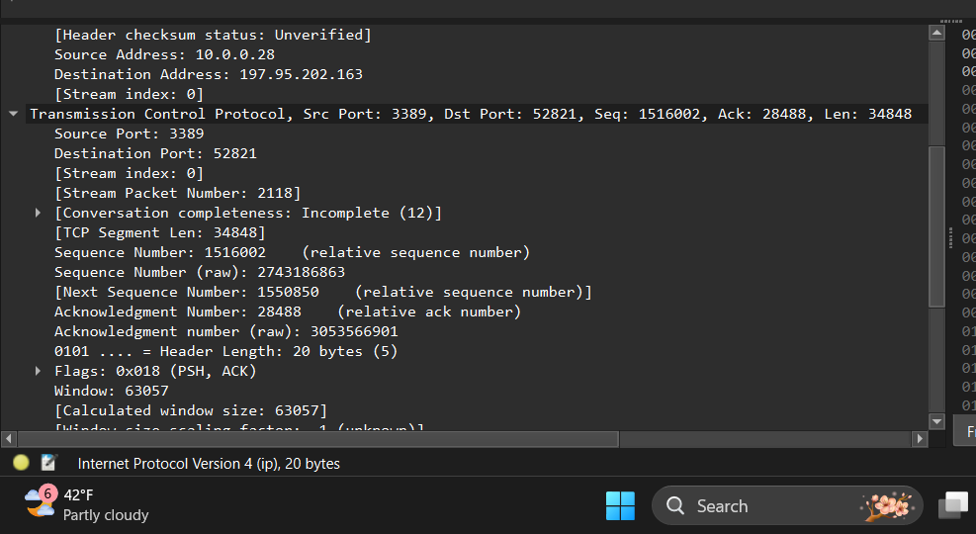

**What is the source IP address? The destination IP address?**

* Source IP address: 10.0.0.28
* Destination IP address: 197.95.202.163

**In the TCP header, which flags are set in the TCP segment?**

* (PSH, ACK)

#### Capstone project 5-2: Build a Packet Tracer Network

* The network simulation was built using Cisco Packet Tracer. (Cisco Networking Academy, 2024)

**Screenshot of Network:**

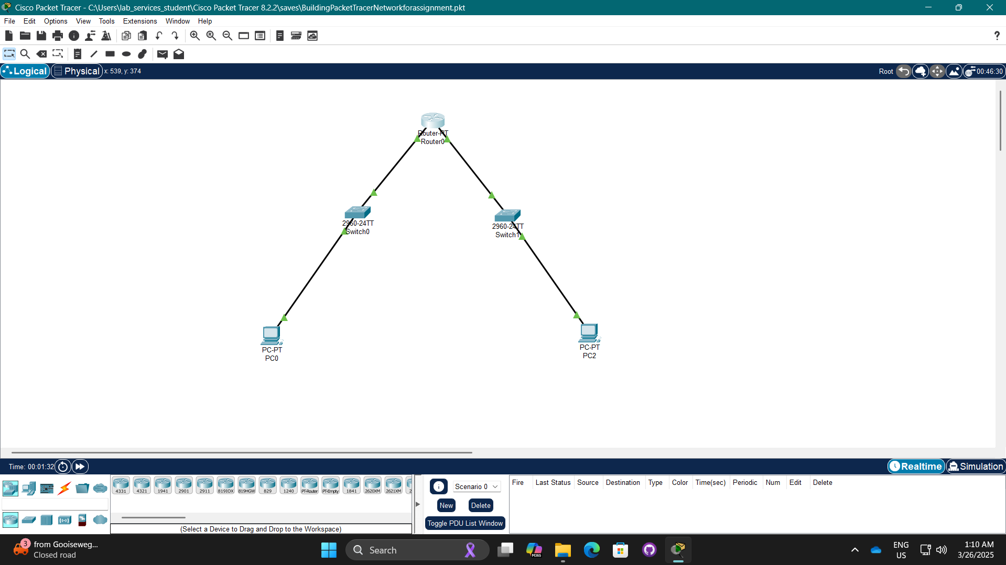

**Screenshot of Router0’s interface configurations:**

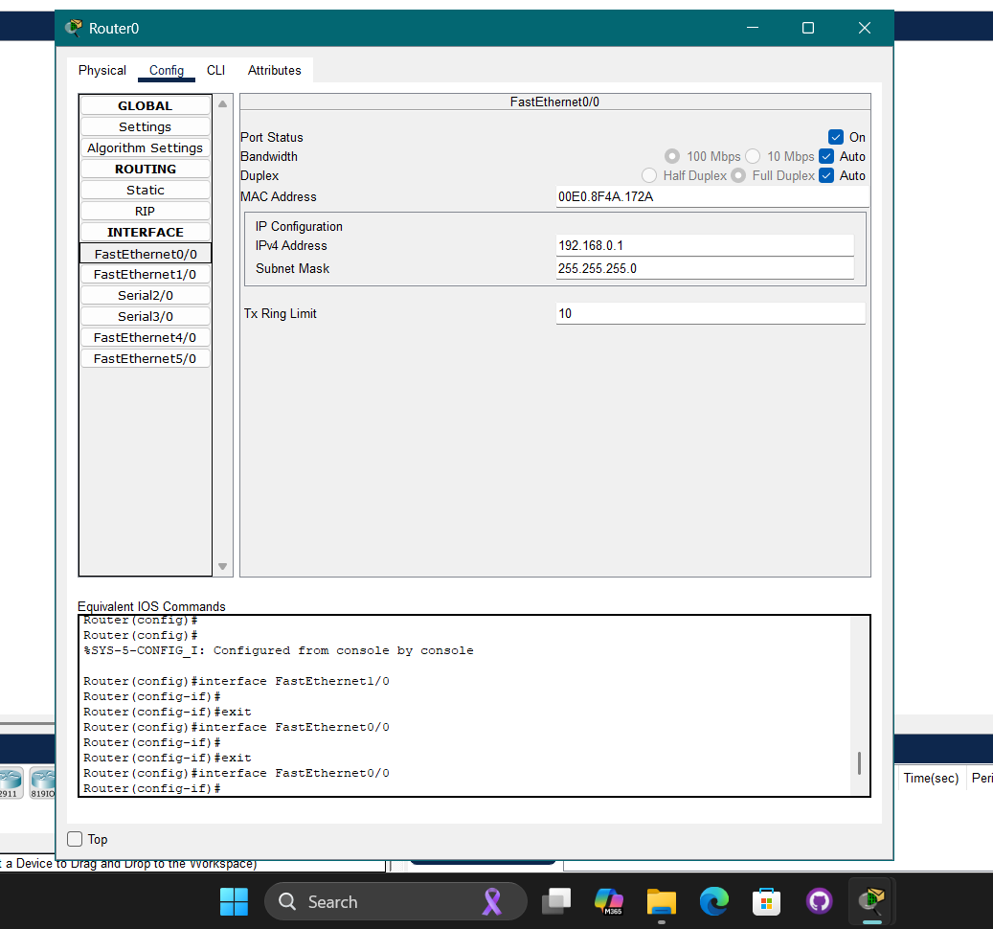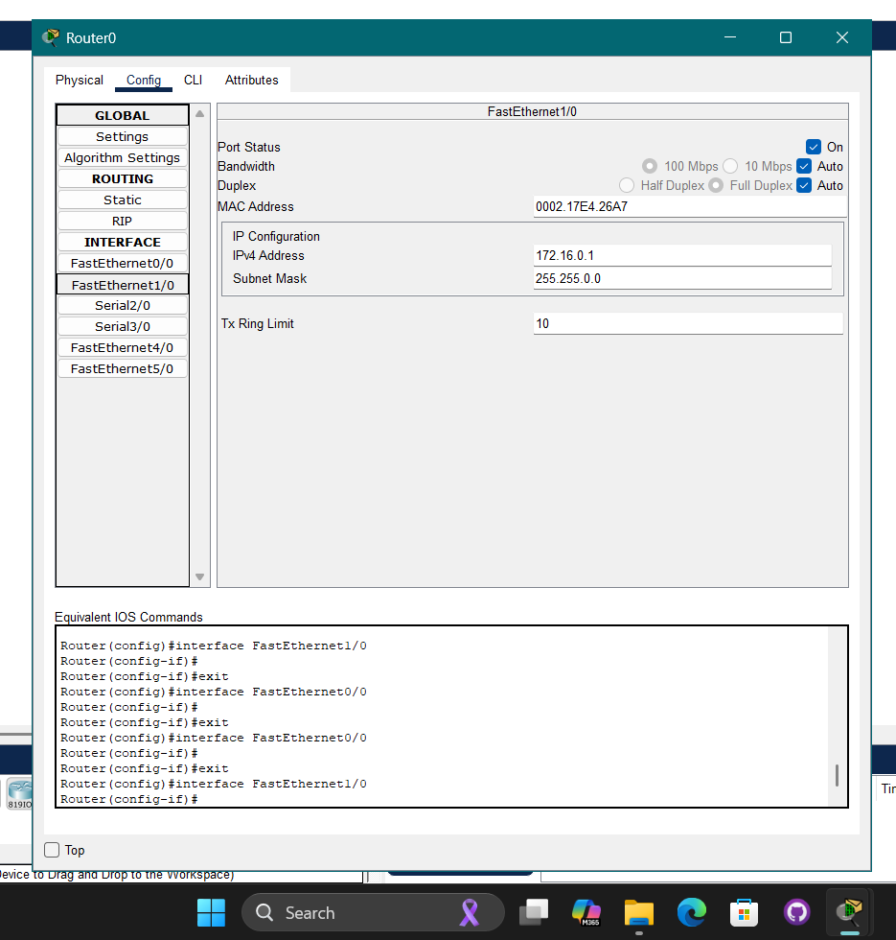

**Screenshot of the IP configuration and the ipconfig results for PC0:**

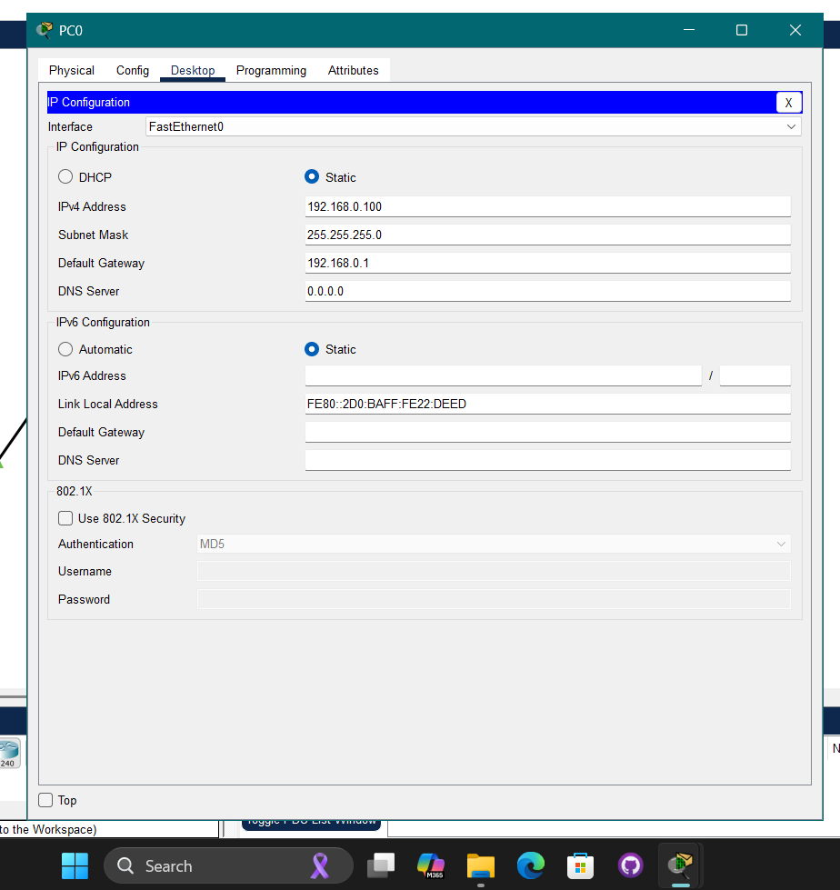

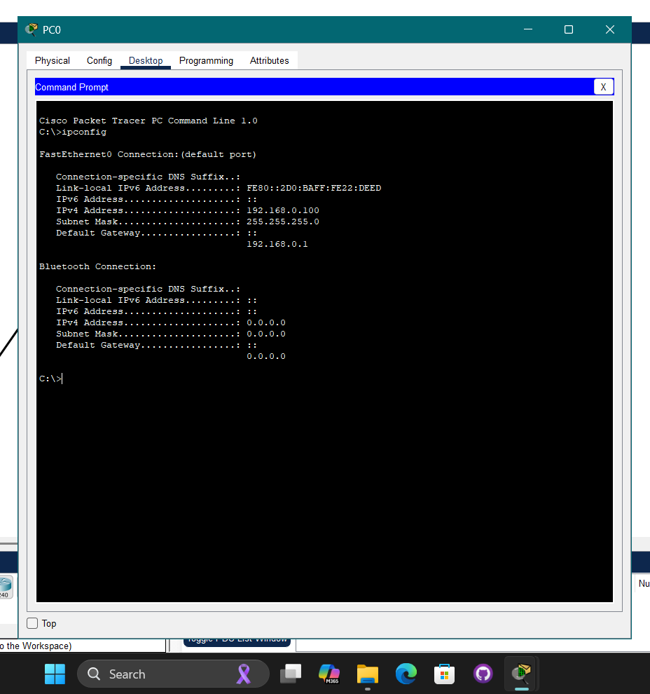

**Screenshot of the IP configuration and the ipconfig results for PC2**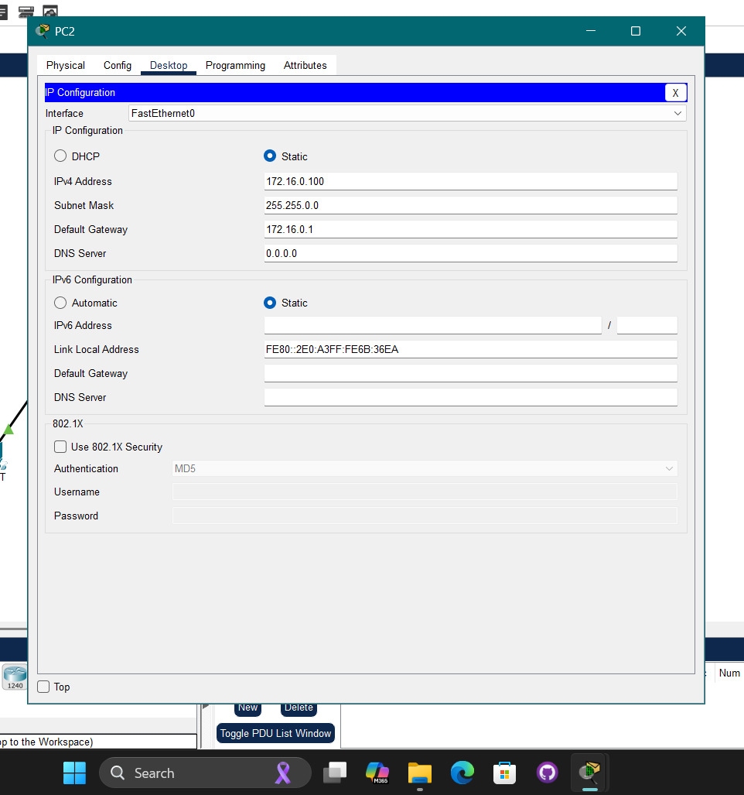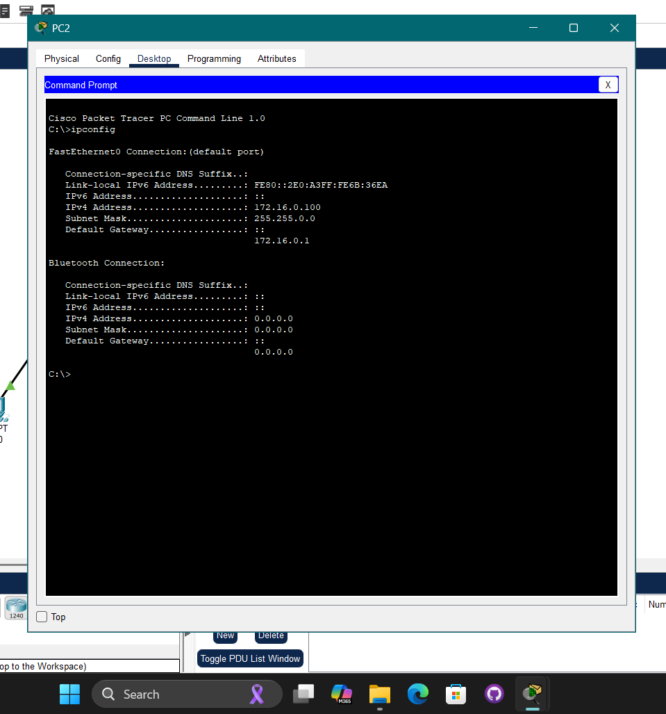

**Screenshot of testing the connection with ping:**

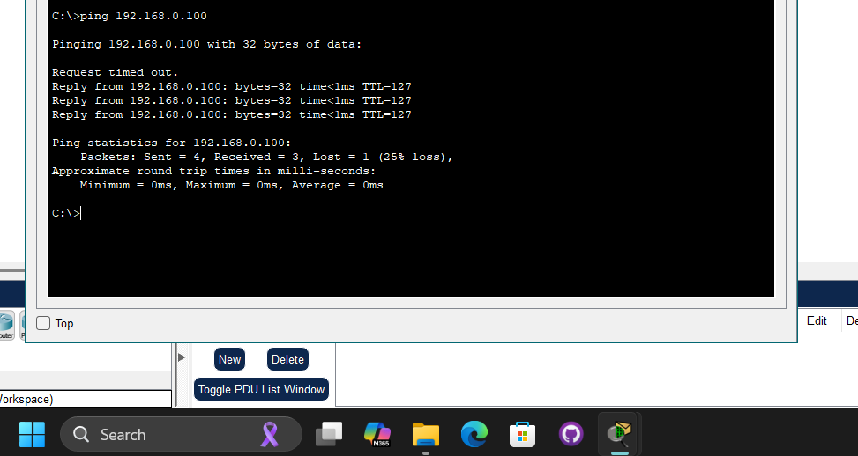

**Was the ping successful?**

* Yes, the ping was successful as packets were sent and received packets although one packet was lost.

**Screenshot of simulation:**

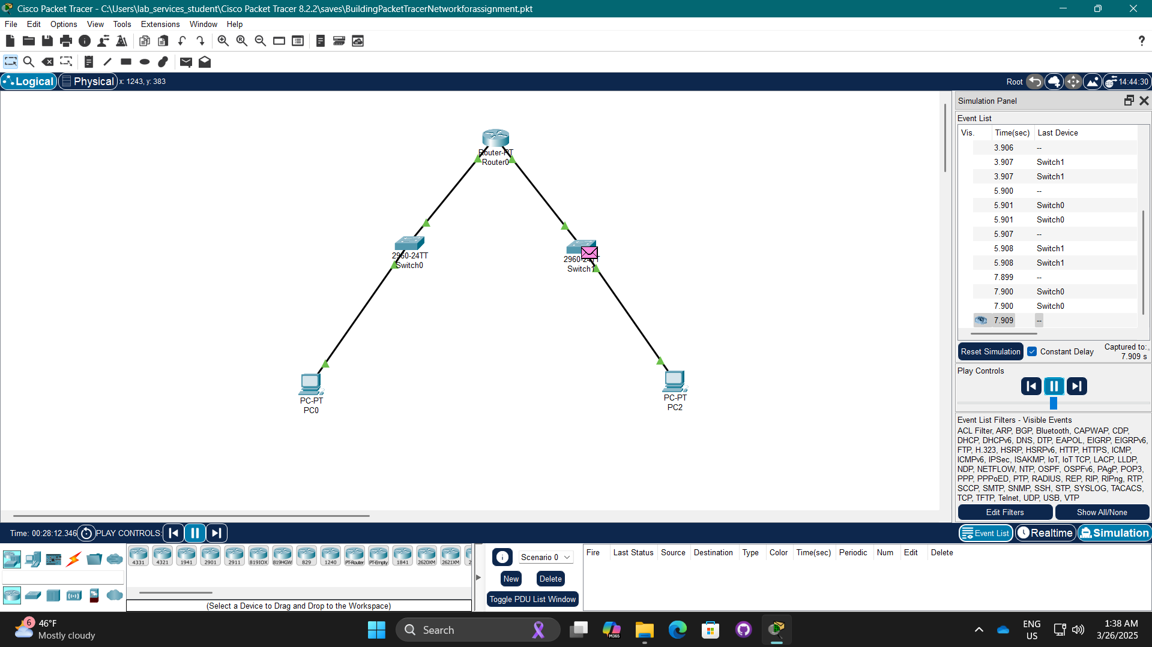

**Screenshots of ICMP Messages:**

**ICMP message 1:**

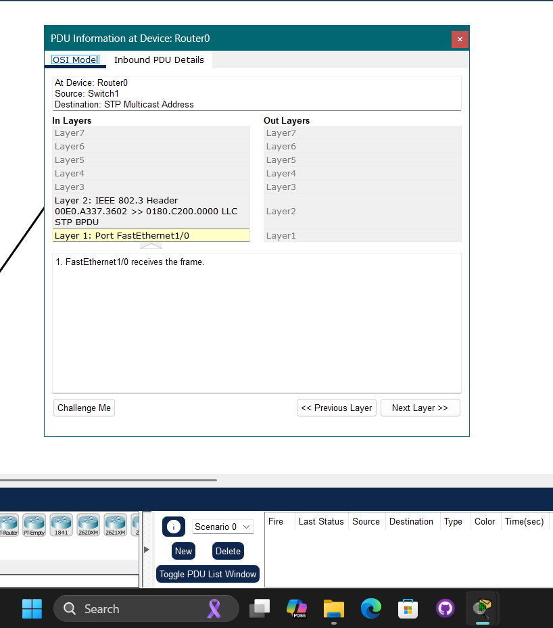

**Which two devices are exchanging each message (sender and receiver)?**

* Sender: Switch1
* Receiver: Router0

**Which OSI layers added headers to each message?**

* Layer 1
* Layer 2

**ICMP message 2:**

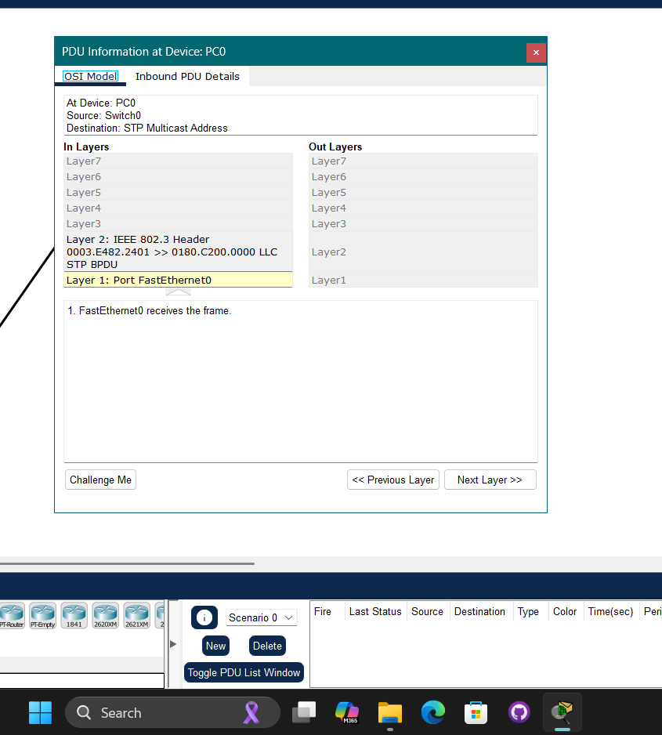

**Which two devices are exchanging each message (sender and receiver)?**

* Sender: Switch0
* Receiver: PC0

**Which OSI layers added headers to each message?**

* Layer 1
* Layer 2

**ICMP message 3:**

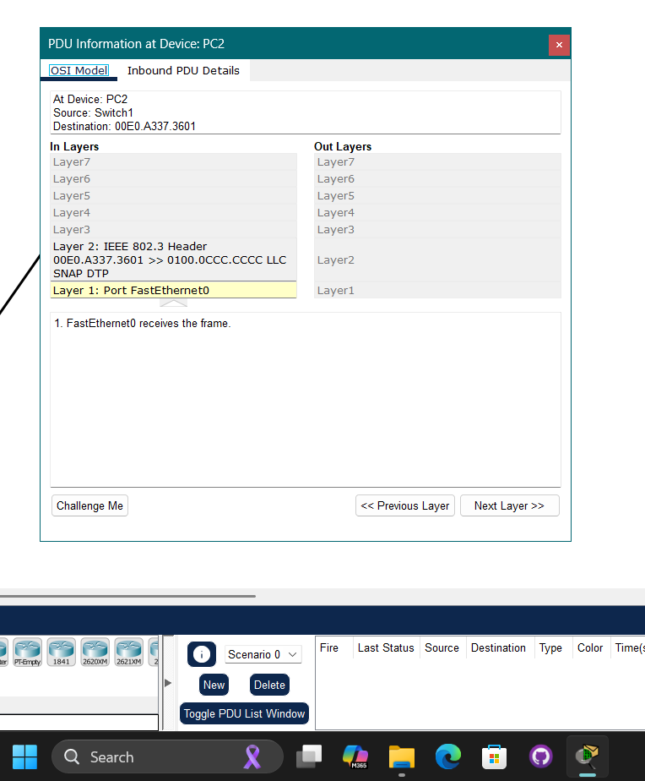

**Which two devices are exchanging each message (sender and receiver)?**

* Sender: Switch1
* Receiver: PC2

**Which OSI layers added headers to each message?**

* Layer 1
* Layer 2

**Screenshot showing notes on connections**

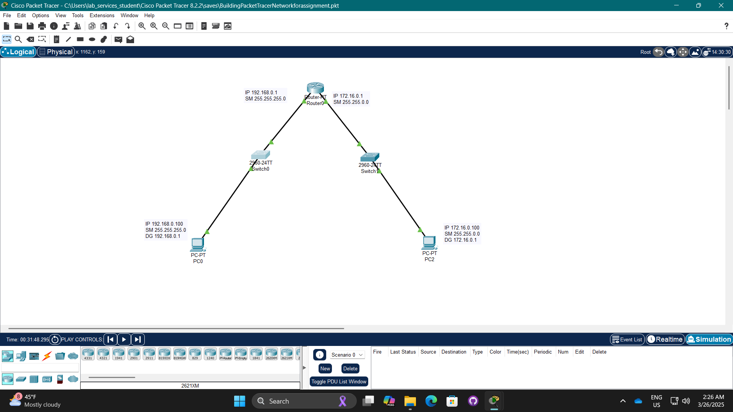

**Screenshot of saved file:**

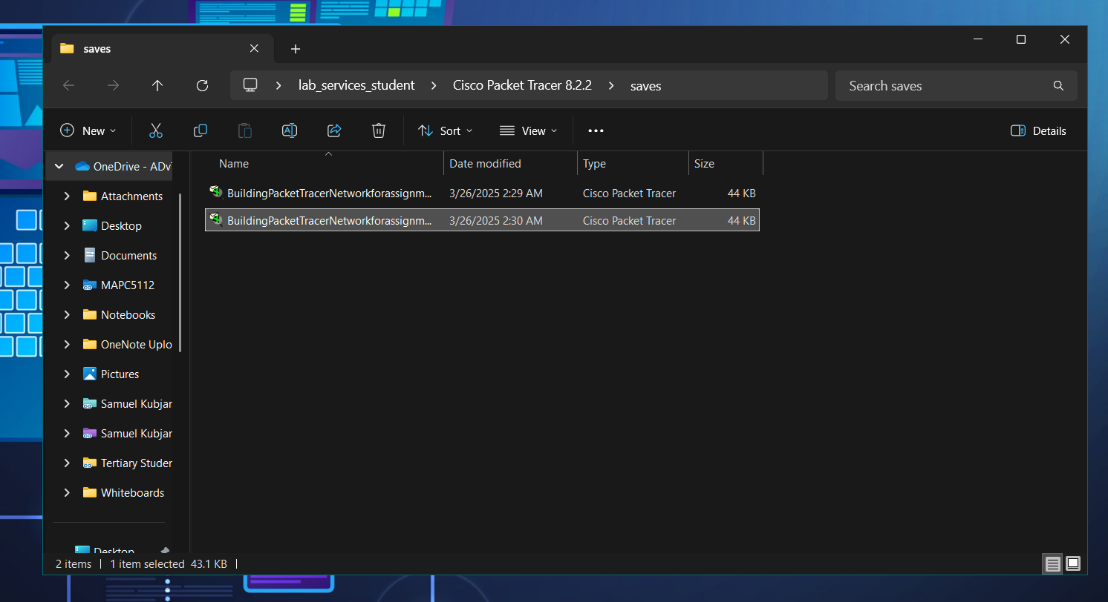

**What is the name of your Packet Tracer file?**

* File Name: BuildingPacketTracerNetworkforassignmentWithNotes

**Screenshot of Wikidot website with added file and notes:**

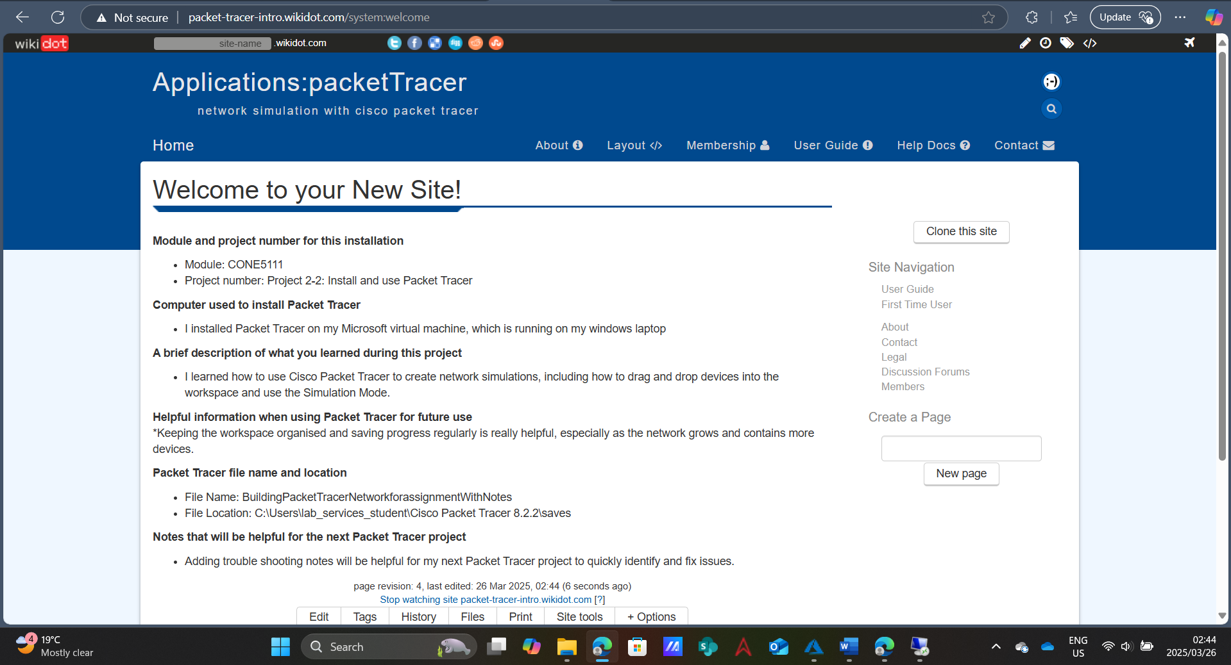

#### Capstone Project 3-2: Build a MAC address on Packet Tracer

* The MAC address was built on Cisco Packet Tracer. (Cisco Networking Academy, 2024)

**Screenshot of entries listed in the MAC address table:**

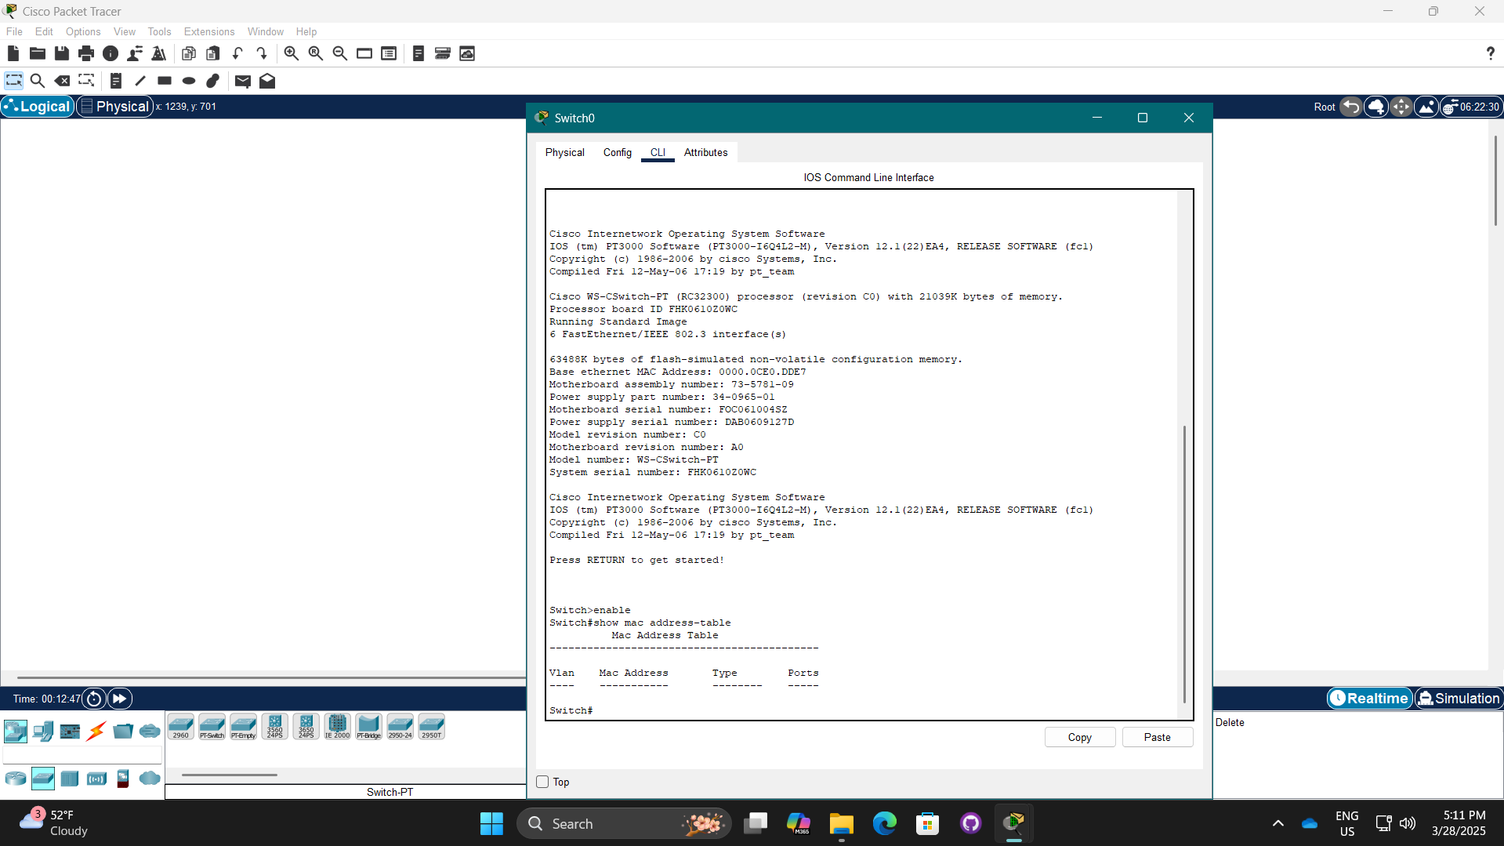

**What entries are listed?**

* No entries are listed

**Screenshot of MAC address table after adding and connecting PC0 and PC1:**

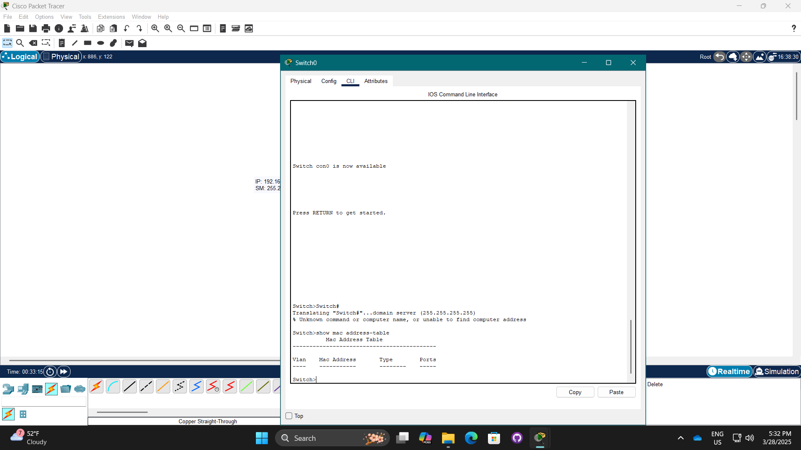

**What entries are listed?**

* No entries are listed

**Screenshot of MAC address table after PC0 pings PC1:**

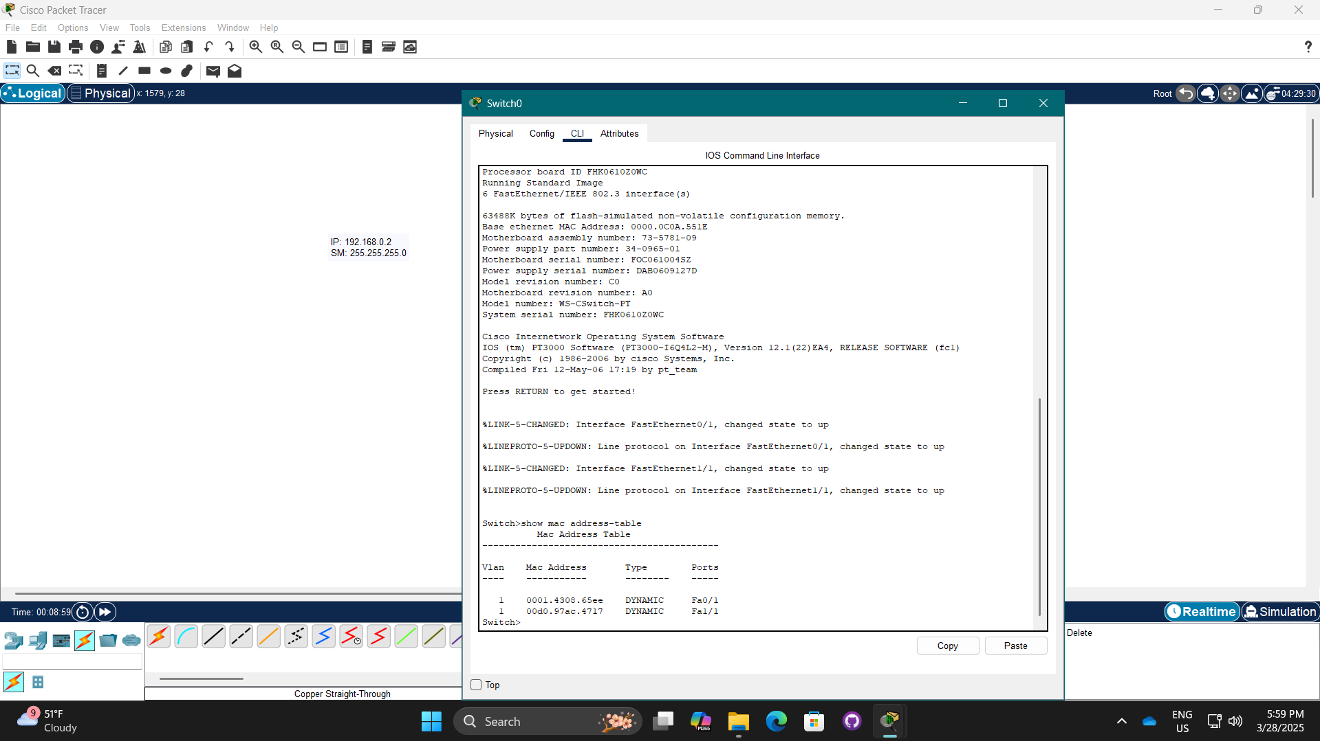

**Screenshot of MAC address table after adding Switch1 & PC2:**

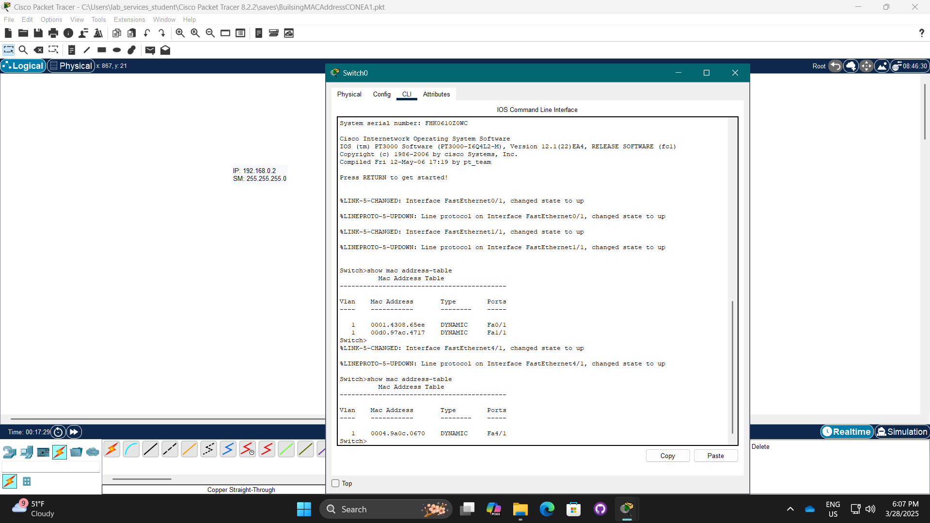

**What entries are listed?**

* 0004.9a0c.0670

**Which connected device is Switch0 currently aware of?**

* PC2

**Screenshot of MAC address table after PC2 pings PC0:**

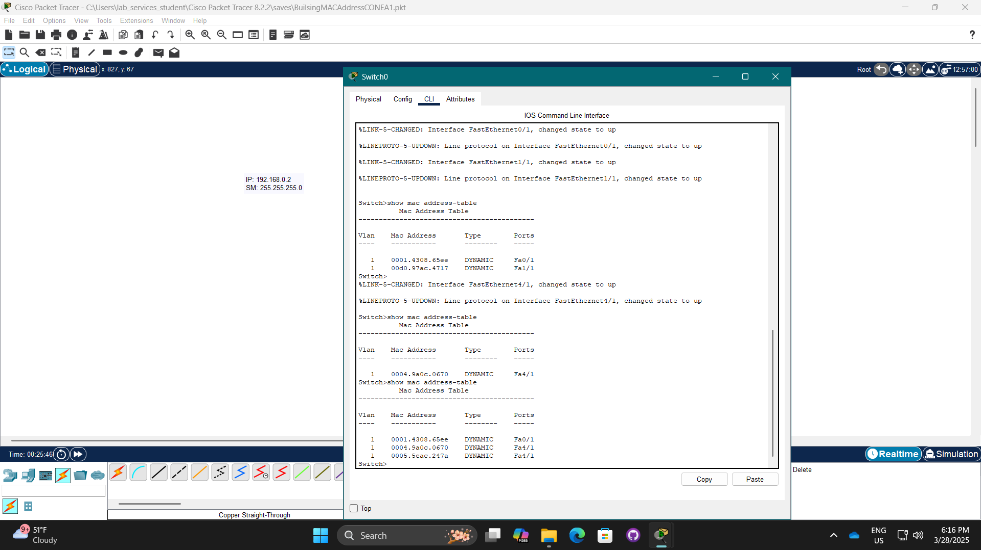

**How many devices is Switch0 currently aware of?**

* 3

**Which device is connected to Switch0’s Fa0/1 interface?** **How can you confirm which device matches this MAC address?**

* The device with the MAC address 0001.4308.65ee which is PC0, and I can confirm which device matches this MAC address as I checked the devices information under the Config tab

**Which two devices communicated across Switch0’s Fa4/1 interface?**

* The devices with MAC addresses 0004.9a0c.0670 which is Switch1 and 0005.5eac.247a which is PC2

**Currently, PC1 is not showing in Switch0’s MAC address table. What can you do to make Switch0 aware of PC1?**

* Ping PC2 on PC1

**Screenshot of MAC address table after PC2 pings PC1:**

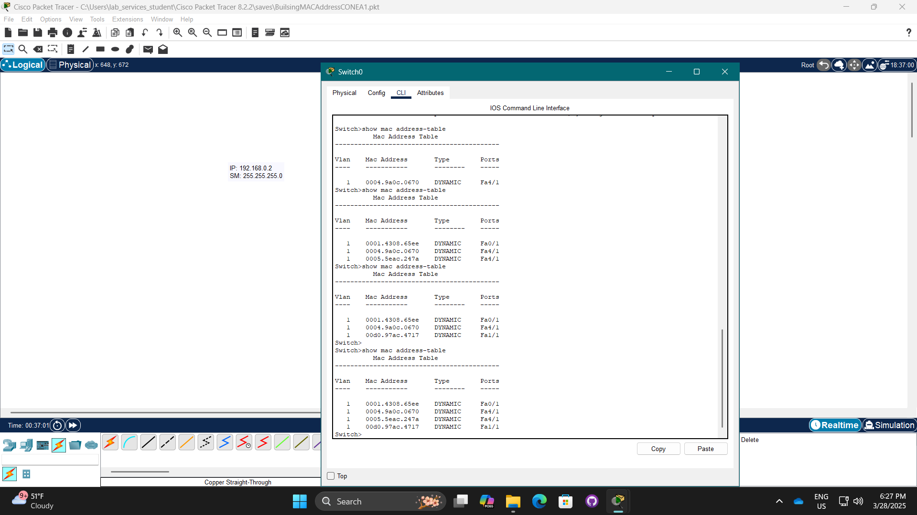

**Screenshot of notes in Wikidot website:**

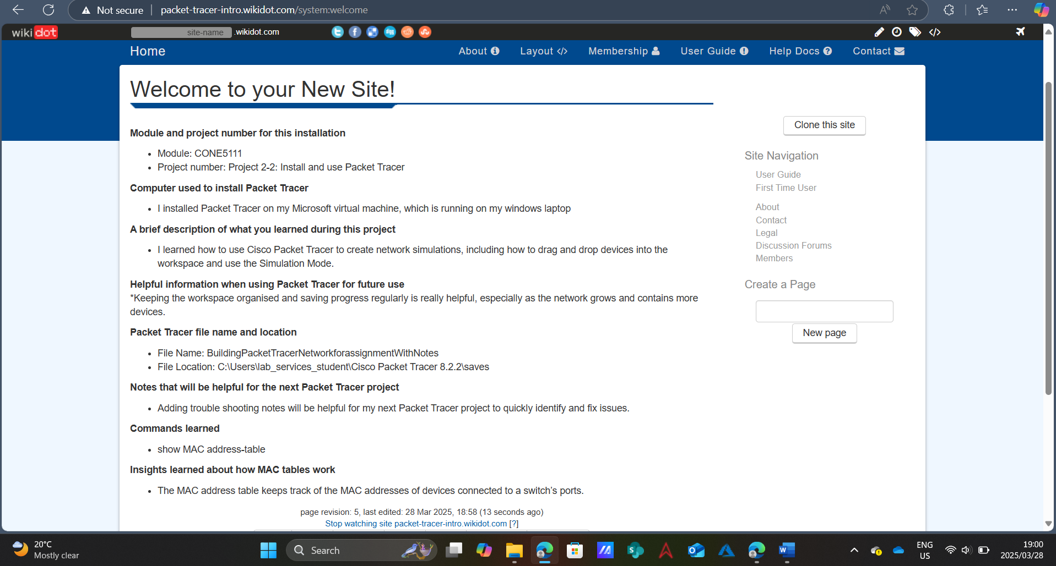

# Reflection Report

For this assignment, I was required to create a network for a new Library and Multimedia Technology Center proposed for two different locations. In this situation, I was tasked with developing the network installation plan, selecting the appropriate hardware, designing the cabling installation plans, and give explanations for my choices based on the needs of the proposed Library and Multimedia Technology Center. Lastly, I had to develop an elaborate network diagram and complete capstone projects that involved the use of practical industry tools used in the IT field.

Initially I felt a bit overwhelmed with the assignment as I attempted to put the physical network diagram together. I resolved this situation by developing a rough floor plan by hand that would help me visualise where everything fit into the layout. I also used AI tools so that I could have a better understanding of what was required for the assignment and to help me see all the pieces of the capstone projects step by step. For me, the most enjoyable aspect of the assignment was using Wireshark as it allowed me to view how devices were communicating and how to analyse the different protocols used in the process of the devices communicating.

This assignment allowed me to get more comfortable with the technical aspect of networking, as it provided more hands-on experience and allowed me to understand how to design network layouts, use Ubuntu and Windows VMs to manage VM systems, use Wireshark to analyse network traffic, scan networks using Nmap, and have working Packet Tracer simulations.

This assignment also improved my soft skills apart from the technical knowledge that I gained throughout this assignment as well, it not only improved my time management using a weekly planning approach but also improved my overall research skills using various methods to understand everything.

There were various technologies and software that I used for this assignment. I used my personal laptop and iPad to sketch diagrams, I used Microsoft Word to document, while I used Nmap, Wireshark, Cisco Packet Tracer, Hyper-V, and both Ubuntu and Windows virtual machines for the capstone Projects.

Overall, this assignment was a bit different from the usual theory-based learning. It forced me to use the theoretical learning I had gained in a real-world situation. I had a few challenges along the way, and learned how to work through those challenges, and feel like I have built better confidence in my ability to do such. Using applications like Wireshark and Packet Tracer gave a great perspective to how networks work, and working through the capstone projects allowed me to reinforce the concepts and not just think or read about them. I improved my organisational and time management skills as I broke different aspects of the tasks down so I could prioritise the list to stay organized and on task. I also improved my research skills, and both will help me as I attempt assignment 2.

# Bibliography

Accutech Communications, 2024. *Backbone Cabling: Top 10 Essential Facts in 2024.* [Online]   
Available at: https://accutechcom.com/backbone-cabling/#:~:text=This%20cabling%20system%20ensures%20that%20the%20backbone%20of,various%20network%20components%20to%20facilitate%20high-speed%20data%20transfer.  
[Accessed 16 March 2025].

Amor Serv, n.d. *Horizontal Structured Cabling: A Comprehensive Guide for Modern Network Infrastructure.* [Online]   
Available at: https://amorserv.com/insights/horizontal-structured-cabling-a-comprehensive-guide-for-modern-network-infrastructure  
[Accessed 16 March 2025].

Ascent Optics, 2024. *“Network Toner and Probe Kit: Essential Cable Tester for Professionals”.* [Online]   
Available at: https://ascentoptics.com/blog/cable-toner/#:~:text=Employing%20a%20tone%20generator%20and%20probe%20kit%20enables,defective%20connections%2C%20and%20check%20cables%20for%20cross%20connections.  
[Accessed 16 March 2025].

Ascent Optics, 2024. *The Ultimate Guide to Choosing the Right Patch Cables for Your Network.* [Online]   
Available at: https://ascentoptics.com/blog/patch-cables/#:~:text=Networking%20patch%20cables%20are%20small%2C%20bendable%20electrical%20wires,to%20allow%20for%20smooth%20communication%20and%20network%20integrity.  
[Accessed 16 March 2025].

Cable data sheet, 2025. *What are the Ethernet Standards?.* [Online]   
Available at: https://www.cabledatasheet.com/faq-about-cable/what-are-the-ethernet-standards/  
[Accessed 16 March 2025].

Cisco Networking Academy, 2024. *Cisco Packet Tracer (Version 8.2.2)* [Software].

[Accessed 25 March 2025].

Click-Telecom, 2024. *Guides for Internet & Communications.* [Online]   
Available at: https://click-telecom.co.uk/guides/what-is-an-access-point/  
[Accessed 08 March 2025].

CloudFlare, n.d. *What is a DNS record?.* [Online]   
Available at: https://www.cloudflare.com/en-gb/learning/dns/dns-records/  
[Accessed 14 March 2025].

Computer Hope, 2024. *Domain namespace.* [Online]   
Available at: https://www.computerhope.com/jargon/d/domaname.htm  
[Accessed 13 March 2025].

Computer Networking Notes, 2024. *Client-Server Networks Model Explained.* [Online]   
Available at: https://www.computernetworkingnotes.com/networking-tutorials/client-server-networks-model-explained.html  
[Accessed 08 March 2025].

Dynamic group, n.d. *What is a Multimeter?.* [Online]   
Available at: https://www.dynamicgroup.net.au/what-is-a-multimeter/  
[Accessed 16 March 2025].

Fiber Optic Systems, n.d. *Fiber Optic Transceivers and Networks Guide.* [Online]   
Available at: https://www.fiberopticsystems.com/transceivers-in-fiber-optic-networks-fundamentals-and-applications#content  
[Accessed 16 March 2025].

FreeCodeCamp, 2020. *What is Nmap and How to Use it – A Tutorial for the Greatest Scanning Tool of All Time.* [Online]   
Available at: https://www.freecodecamp.org/news/what-is-nmap-and-how-to-use-it-a-tutorial-for-the-greatest-scanning-tool-of-all-time/#:~:text=Nmap%20is%20short%20for%20Network%20Mapper.%20It%20is%20an  
[Accessed 25 March 2025].

Geeks For Geeks, 2024. *Advantages and Disadvantages of Tree Topology.* [Online]   
Available at: https://www.geeksforgeeks.org/advantages-and-disadvantages-of-tree-topology/  
[Accessed 08 March 2025].

Gordon Lyon, 2023. *Nmap-Zenmap GUI (Version 7.95.).* [Software].

[Accessed 25 March 2025].

How To Geek, 2023. *IPv4 vs. IPv6: What Are the Differences?.* [Online]   
Available at: https://www.howtogeek.com/901201/ipv4-vs-ipv6/  
[Accessed 14 March 2025].

Jabbercomm, 2024. *The Ultimate Guide to Different Types of Cable Testers.* [Online]   
Available at: https://www.jabbercomm.com/blog/the-ultimate-guide-to-different-types-of-cable-testers/#:~:text=Network%20cable%20testers%20are%20multifunctional%20devices%20designed%20to,on%20cable%20length%2C%20wiring%20configurations%2C%20and%20signal%20integrity.  
[Accessed 16 March 2025].

Kinsta, 2024. *What Is a Nameserver? Why Are Nameservers Important?.* [Online]   
Available at: https://kinsta.com/knowledgebase/what-is-a-nameserver/#:~:text=Nameservers%20help%20connect%20URLs%20with%20the%20IP%20address,people%20call%20the%20%E2%80%9Cphone%20book%20of%20the%20Internet%E2%80%9D.  
[Accessed 14 March 2025].

Microsoft , 2023. *Microsoft Visio web version.* [Online]   
Available at: https://www.microsoft.com/en-us/microsoft-365/visio/flowchart-software  
[Accessed 22 March 2025].

Microsoft, 2024. *Hyper-V (Version 2019)* [Software].

[Accessed 25 March 2025].

NAKIVO, 2021. *Types of Network Topology Explained.* [Online]   
Available at: https://www.nakivo.com/blog/types-of-network-topology-explained/  
[Accessed 08 March 2025].

netacad, n.d. *Getting Started with Cisco Packet Tracer.* [Online]   
Available at: https://www.netacad.com/launch?id=ec0847b7-e6fc-4597-bc31-38ddd6b07a2f&tab=curriculum&view=25930ae2-75a7-50d2-8df1-c36d35fab6a9  
[Accessed 25 March 2025].

Network drops, n.d. *The Different Types of Network Cabling.* [Online]   
Available at: https://networkdrops.com/blog/the-different-types-of-network-cabling/  
[Accessed 16 March 2025].

omnitron-systems, n.d. *Industrial Media Converters vs. Commercial Media Converters: Key Differences.* [Online]   
Available at: https://www.omnitron-systems.com/blog/industrial-media-converters-vs-commercial-media-converters-key-differences#:~:text=Media%20converters%20enable%20seamless%20communication%20between%20copper%20Ethernet,reliability%2C%20and%20ensure%20compatibility%20a  
[Accessed 16 March 2025].

Patch box, 2023. *What are RJ11 connectors? Everything you need to know.* [Online]   
Available at: https://patchbox.com/blog/rj11-connectors/  
[Accessed 16 March 2025].

Sanfoundry, n.d. *Types of Addressing Modes in TCP/IP Model.* [Online]   
Available at: https://www.sanfoundry.com/computer-network-types-of-addressing-modes-in-tcp-ip-model/  
[Accessed 14 March 2025].

Server Watch, 2023. *What Is a Server? | Definition, Types, and Features.* [Online]   
Available at: https://www.serverwatch.com/guides/what-is-a-server/  
[Accessed 08 March 2025].

SocPub, 2025. *10 Essential Cable Management Tips for IT Professionals.* [Online]   
Available at: https://socpub.com/articles/10-essential-cable-management-tips-it-professionals-18031  
[Accessed 16 March 2025].

Spice Works, 2023. *What Is Peer-To-Peer? Meaning, Features, Pros, and Cons.* [Online]   
Available at: https://www.spiceworks.com/tech/networking/articles/what-is-peer-to-peer/  
[Accessed 08 March 2025].

Spice Works, 2025. *What Is Network Hardware? Definition, Architecture, Challenges, and Best Practices.* [Online]   
Available at: https://www.spiceworks.com/tech/networking/articles/what-is-network-hardware/#:~:text=Network%20hardware%20is%20a%20set%20of%20physical%20or,enable%20a%20network%20to%20function%20effectively%20and%20efficiently.  
[Accessed 08 March 2025].

The Knowledge Academy, 2025. *What is Star Topology: Key Features, Working, and Benefits.* [Online]   
Available at: https://www.theknowledgeacademy.com/blog/star-topology/#:~:text=Star%20Topology%20is%20a%20network%20configuration%20where%20each,repeater%20and%20manages%20data%20traffic%20between%20the%20devices.  
[Accessed 08 March 2025].

Unstop, n.d. *Difference Between Classful Addressing And Classless Addressing.* [Online]   
Available at: https://unstop.com/blog/classful-addressing-versus-classless-addressing  
[Accessed 14 March 2025].

West, J., 2022. CompTIA Network+ Guide to Networks. In: 9th ed. ed. Boston: Cengage Learning, pp. 62,63,64.

WhatIsMyIP, n.d. *What Is an RJ45 Connector?.* [Online]   
Available at: https://www.whatismyip.com/rj45-connector/  
[Accessed 16 March 2025].

Wireshark Foundation, 2023. *Wireshark (Version 4.4.5).* [Software]

[Accessed 25 March 2025].

Wiringo, n.d. *Continuity Test: A Complete Guide of Its “What” And “How-to-do”.* [Online]   
Available at: https://www.wiringo.com/continuity-test.html  
[Accessed 16 March 2025].